Parenting in a Pandemic: Juggling Multiple Roles and Managing Technology Use in Family Life During COVID-19 in the United States
402
REBECCA MICHELSON, Human-Centered Design and Engineering, University of Washington, USA
AKEIYLAH DEWITT, Human-Centered Design and Engineering, University of Washington, USA
RIA NAGAR, Georgia State University, USA
ALEXIS HINIKER, Information School, University of Washington, Seattle, Washington, USA
JASON YIP, Information School, University of Washington, Seattle, Washington, USA
SEAN A. MUNSON, Human-Centered Design and Engineering, University of Washington, USA
JULIE KIENTZ, Human-Centered Design and Engineering, University of Washington, USA
The COVID-19 pandemic upended the lives of families with young children as school closures and social distancing requirements left caregivers struggling to facilitate educational experiences, maintain social connections, and ensure financial stability. Considering families’ increased reliance on technology to survive, this research documents parents’ lived experiences adapting to technology’s outsized role alongside other shifts in family life associated with the COVID-19 pandemic. In this paper, we describe a 10-week study with 30 enrolled families with children aged 3 to 13 in the United States using the asynchronous remote communities (ARC) methodology to 1) understand the benefits and challenges faced by families as they adapted technology at home to navigate the pandemic, and 2) to ideate improvements to those experiences through co-design. We found that amidst gaps in infrastructural support from schools, workplaces, and communities, parents experienced deep anxiety and took on new roles, including tech support, school administrator, and curator of meaningful activities for their children. As parents shared bold and creative technology-based solutions for improving family well-being, schooling experiences, social life, and beyond, they demonstrated their capacity to contribute to new models of learning and family life. Our findings are a call to action for CSCW researchers, designers, and family-focused practitioners to work with learning communities that incorporate parent, teacher, and technology experiences in their academic and community planning.
CCS Concepts: • Human-centered computing • Collaborative and social computing • Applied computing • Education • Distance learning
KEYWORDS: Families, Children; Co-design; Asynchronous Remote Communities; Pandemic; COVID-19; Remote Learning
ACM Reference format: Rebecca Michelson, Akeiylah Dewitt, Ria Nagar, Alexis Hiniker, Jason Yip, Sean A. Munson and Julie Kientz. 2021. Parenting in a Pandemic: Juggling Multiple Roles and Managing Technology Use in Family Life During Covid-19 in the United States. In Proceedings of the ACM on Human-Computer Interaction, Vol. 5, CSCW2, Article 311 (October 2021), 39 pages, https://doi.org/10.1145/3479546
This work is supported by the National Science Foundation, under the RAPID grant 2027525.
Author’s addresses: Rebecca Michelson, 428 Sieg Building Campus Box 352315 Seattle, WA 98195.
Permission to make digital or hard copies of all or part of this work for personal or classroom use is granted without fee provided that copies are not made or distributed for profit or commercial advantage and that copies bear this notice and the full citation on the first page. Copyrights for components of this work owned by others than the author(s) must be honored. Abstracting with credit is permitted. To copy otherwise, or republish, to post on servers or to redistribute to lists, requires prior specific permission and/or a fee. Request permissions from Permissions@acm.org.
2573-0142/2021/October - ART402 $15.00
© Copyright is held by the owner/author(s). Publication rights licensed to ACM.
https://doi.org/10.1145/3479546
- INTRODUCTION
As the COVID-19 pandemic unfolded, millions of children adapted to learning from home during “shelter-in-place” laws while their parents negotiated a range of work needs—such as being laid off, experiencing furlough, working remotely, or facing increased work demands as essential workers. Before the pandemic, community infrastructures provided support with basic everyday living, for example, schooling, extracurricular activities, socializing, and healthcare. In the wake of the pandemic, parents were left to fill the gaps left by public support systems, with compounding effects of stress and pressures. While schools determined their technology systems and class schedules, parents often had to fill in the gaps for teachers and classrooms, adjust their home environments, and determine their new daily routines.
The pandemic abruptly eliminated school resources that parents relied on, like childcare, a safe environment, and food. As a New York Times article described, “parents have to play teacher’s aide, hall monitor, counselor and cafeteria worker — all while trying to do their own jobs under extraordinary circumstances”. The transitions in and out of lockdowns have not been easy for parents. During the pandemic, over one-third of working parents reported struggling with handling childcare responsibilities [30]. Because parental decisions and household maintenance needs are mediated by technology, our study sought to understand to what extent technology enabled or hindered adapting family life during the pandemic. While there is emerging research on the impacts of COVID-19 on schooling, higher-education [23], and long-term “learning loss” [20], HCI-related literature to family-based impacts during a collective trauma, such as this pandemic, are needed. Advancing knowledge on the situated experiences of family life during crises, such as COVID-19, can inform strategic decisions on pedagogical, technical, and community-based support implementations in preparation for future crises.
This exploratory study asked families to reflect on their experiences from a holistic perspective: from reflections on daily interactions with technology to mapping their information and resource systems. While schools and employers rushed to implement technology-based solutions during the pandemic, we sought to understand some of the primary social, emotional, and structural concerns that families faced in juggling competing work, parenting, and self-care needs alongside new technologies - without the typical support from community-based organizations. Studying these infrastructural gaps from families’ perspectives can inform future designs of remote learning technologies and community-based support for families. The CSCW and broader HCI communities have written extensively on family-centered technologies, from researching screen-time norms to analyzing parental control and mediation strategies to studying family health informatics [24, 33, 51, 53]. While existing literature reveals parents’ common technology-related concerns, strategies, and needs, our research illuminates the compounding effects of the COVID-19 pandemic as a crisis, which complicates parents’ efficacy and wellbeing in family life. Our empirical contribution also reveals opportunities to work across community stakeholders (employers, school administrators, community-based organizations, etc.) to support parents in filling multiple roles while sheltering-in-place. This paper provides data into primary user experience concerns in remote learning. Specifically, we focus on increases in cognitive load from taking on additional work concerns and reproductive labor (including domestic work and caregiving labor) that parents faced during the pandemic. We find an increase in mental health strain, as parents navigate personal and collective news related to COVID-19, negotiate social life needs, ensure healthcare needs are met, and adjust expectations for daily life amidst deep uncertainty.
The research presented in this paper is part of a larger study that explored the evolving roles of parents as the pandemic as unfolded. Specifically, we examined how parents negotiated work needs, childcare needs, and learning and enrichment needs along with the role of technology in facilitating these changing circumstances. In this paper, we focus on the following research questions:
- How did families leverage and adapt technology during the first 4 months of the pandemic in the United States, and what successes and challenges have they experienced?
- What technology-supported potential solutions do families envision to address their needs during times of crisis and prolonged social isolation?
We present how parents’ roles multiplied, some as providers for their family and others as the main taskmasters (taking care of day-to-day needs such as virtual doctor’s appointments, mealtimes, and chores), often while also acting as school administrators and information technology support for their children. We also share family-generated ideas for easing the mental burdens of making these adjustments.
- RELATED WORK
The COVID-19 pandemic presented a unique set of circumstances—including physical distancing guidelines and both the availability of and reliance on virtual technologies. Yet our work draws on and is inspired by previous research in family-based HCI and CSCW literature on designing for caregivers and parent decision-making.
  - Designing for Caregiving and Family Coordination
Prior HCI literature has studied family coordination, informatics, and caregiving in primarily non-crisis, pre-pandemic settings. This work has focused primarily on parent or child experiences independently and less on the opportunity for technology to mutually benefit both parents and their children. For example, family tracking research has identified concerns about balancing children's needs for privacy with the parents’ desires for monitoring safety to prevent danger [12]. Similarly, CSCW research has advocated for a more family-centered approach to caregiving that includes empowering children in their own caregiving activities [53]. While some studies have focused on child autonomy, others have emphasized the need for caregivers to also receive structural, technical, self-care, and mental health support [63]. Family-centered design can encourage mutual benefits for caregivers and children through clarity in communicating boundaries, supporting shared family tasks, and implementing as well as reinforcing routines [65]. CSCW research using co-design with caregivers and children reinforces the effectiveness of the method to engage each population independently through reflection and ideation sessions on topics of caregiving and family coordination [38, 71]. These family multi-stakeholder processes illuminate where family members are similar or different in their needs and preferencing, thus broadening the design possibilities. Inspired by and building on this work, our research includes co-design opportunities for caregivers and children to imagine mutually beneficial support together during a unique world event.
  - Parent Mediation of Technology and Decision-Making
Researchers have studied shifts in technology mediation and decision-making strategies within publications in CSCW, communication theory and sociology journals, and studies of digital youth and parental mediation practices. For example, Jennifer Lois studied a homeschooling support group for mothers, highlighting the tradeoffs mothers face when their role as their child’s teacher strains their role as a mother, specifically when responding to education-driven parenting challenges, like low student motivation and maintaining progress alongside conventionally educated peers [46]. Other researchers have investigated how parents make decisions for their children while balancing competing needs, such as child autonomy and parental approval of media content. Clark presented two experimental applications of social values theory to understand parent decision making structures, finding that many parents make decisions that pose the least risk to inconvenience their child [17]. Parents also rely extensively on their intuition and support networks in making decisions about their child’s health and well-being, but turn to external resources when they are uncertain, perceive a situation to be high-stakes, or encounter a new situation [41], all circumstances that families experienced as consequences of the COVID-19 pandemic. Family dynamics also shift around increased technology and digital media use: Schiano et al. found that technology addiction was a primary concern among parents [59]. Children have been involved in co-designing new tools for mediation as well, emphasizing needs for restricting over monitoring, teaching risk coping, promoting parent-child communication, and automating interactions [52]. Parents engage in numerous strategies around mediating their children’s technology use [17], setting rules [33] and expectations [51] as a family, and use technology-based solutions to monitor screen time and content with varying degrees of success [24, 25]. Parents and teens often have different perspectives on the values of phone time during shared social moments, contributing to family conflicts and feelings of shame and guilt on both sides. Yet, parents and youth are open to reaching a shared understanding of the role of smartphones in family life [19]. These findings justify the need for direct research on the relationship between decision-making strategies, shifting family dynamics, parental beliefs about screen time, and mediation of school technologies at home. Our work examines these topics in the context of the COVID-19 pandemic.
  - The Difficulties of Online Learning for Children and Families
The closest equivalent to the online learning situation in COVID-19 may be the research in online education during pre-COVID times. Prior to COVID-19, online education and distance learning has been a fast-rising opportunity for families and children to engage in learning without going to a physical classroom [8, 28, 58]. Often these online school opportunities allow for more enrollment across borders and boundaries [37]. Students in online learning environments engage in multimedia experiences, such as online videos, presentations, electronic documents, and other learning materials. Despite these opportunities, the pedagogical environment of e-schools and online learning often mimics the assignments and homework of traditional school environments [3]. When schools fall back on in-person instruction styles in online environments, this may result in incompatibilities and create more difficulties. This may be born out in evidence that online learning does not necessarily mean better or equivalent learning to physical environments. In one of the largest studies of student enrollment patterns and achievement in Ohio’s charter schools, students in e-schools often performed worse on standardized assessments than peers in traditional charter and traditional public schools [4]. Similarly, in the early 2000s, students in California home-based and online charter schools also seemed to perform worse than in traditional schooling [14, 68]. These findings indicate a need to address the unique context of at-home learning where technologies operate.
Much of what we know about online education is from non-crisis times. During the COVID-19 pandemic, asking children and families to independently work through online learning can impose even more stress to self-regulate learning and manage their own learning processes. This kind of independent self-regulation in online learning spaces is difficult for students, often requiring close scaffolding and guidance before setting out on their own [7]. This issue is only further exacerbated for overworked parents who must help their children develop these metacognitive skills but are unable to do so easily themselves. Therefore, while online learning opportunities have existed for many years, we would expect that online learning supports during a global crisis make new challenges and needs salient.
- METHODS
Starting in April 2020, about one month after schools and businesses in many states in the US began to shut down, we designed and executed a study to examine how families were adapting to the pandemic and the role of technology in this adaptation.
We conducted a 10-week Asynchronous Remote Communities (ARC) study—an online, long-term method in which researchers use a technology platform to facilitate discussion and connect participants. This method allowed us to safely conduct research while shelter-in-place policies were in effect and could also benefit participants by allowing them to share and engage with peer support and informal learning opportunities [48]. Previous ARC studies include working with teens and stress, pregnant mothers, people with HIV, and a hybrid in-person study and ARC with transgender and non-binary youth [11, 45, 49], justifying the effectiveness of the method in engaging vulnerable populations virtually. In our study, we were also excited about the opportunity for the ARC method to connect participants from different demographics and locations. We selected the Slack platform, typically used as a workplace communication tool for this study to preserve anonymity (by supporting the use of pseudonyms) and to support rich media sharing and collaboration that also allowed for multiple platform engagement (e.g., via computers, tablets, or mobile devices). This study was approved by our university’s Institutional Review Board, and families provided consent (parents) or assent (children) to participate in the study.
  - Design Activity Prompts and Procedures
Upon enrolling, families completed an intake survey and joined a Slack group, where they were added to to a private channel with researchers and their co-participants. In addition to recruiting and enrolling participants in the study, we moderated the Slack channel. Over the course of 10 weeks, 30 families in the US answered prompts and participated in co-design activities on topics such as work-related needs, remote schooling, and caregiving mediated by technology (Table 1). Families participated in Slack activities, such as sharing their answers to the prompts and responding to others’ posts, asynchronously. The prompts were intended to build on each other, such that the first few weeks focused on understanding participant needs, the next few weeks included refinement of top concerns parents had, and the final few weeks focused on envisioning design solutions in a collaborative manner.
Table 1. Weekly Activities and their prompts for the Asynchronous Remote Communities on Slack
Phase | Week | Activity Name | Prompt Details | Generative or Recall
Understanding participant needs | 1 | Introductions and Advice | After introducing themselves, parents were asked to share what advice they would have given themselves pre-COVID-19. | Recall
Understanding participant needs | 2 | Diary study | Participants completed five different diary entries on their technology use | Recall
Refining the problems and benefits of technology use | 3 | Ranking and ranting and writing a letter to technology | Participants reviewed a list of top technology-related concerns and benefits (generated from screener survey responses and the diary study entries). They ranked the concerns and wrote a love or break-up letter to a piece of a technology. | Recall and Generative
Refining the problems and benefits of technology use | 4 | Information and resource mapping | Participants created diagrams of their information flows and resources related to work needs, remote schooling (or summer/after-school activities), and COVID-19. | Recall
Study Pause | 5 | Study Pause | Shortly after the murder of George Floyd, we held a study pause for our participants and research team to reflect and protest accordingly. | Generative
Co-design | 6 | Ideation | Through partnered brainstorming, participants created solutions to address some of the most chaotic moments of the pandemic. | Generative
Co-design | 7 | Idea refinement | Participants selected their top ideas and refined them with product names, descriptions, and sketches. | Generative
Co-design | 8 | Mixing ideas: Round 1 | Participants created family technologies about COVID-19, supporting quality family time, addressing anti-racism, or anything else that felt meaningful to them, based on combining ideas shared by others. | Generative
Co-design | 9 | Mixing ideas: Round 2 | Participants completed the “mixing ideas” prompt one more time with the latest batch of ideas shared. | Generative
Reflection | 10 | Letters about Fall 2020 | Participants wrote a letter to their principal based on their desired types of support for remote schooling for Fall 2020. | Generative

We designed the prompts to include both recall and generative activities (including reflection exercises like diary studies or creative writing exercises) to offer variety and different modes of engagement, as encouraged by previous ARC studies [48]. The combination of recall and generative prompts intended to balance meaningful introspection with speculative creativity and social connection. Prompts were also designed to accommodate the often busy, multitasking lives of parents. For example, diary studies are often used to understand in-situ behaviors and interactions with technologies through low-barrier reflections [9, 42, 47]. Diary studies have been used in several family-focused technology studies to inform family-friendly technology design [10, 31]. Our ARC embedded a one-week diary study with daily prompts that asked participants to: pick a technology to review per entry, rate it on a scale of levels of satisfaction, reflect on who was involved in the tech interaction as well as its use case and format, and briefly reflect on any comments and/or issues with the technology.
We designed activities to take up to 20 minutes per week to complete, and we compensated families with a $10 gift card for completing each week’s activity. Several of the researchers regularly posted the weekly Slack prompts, shared reminders for participants to complete their prompts, answered participant questions, and responded to participant posts to stimulate online engagement. For example, during the weeks with co-design activities, researchers followed up on individual participant posts as needed, with reminders about including multimedia attachments in their creative idea submissions. Occasionally, researchers made announcements and shared articles or memes in channels that were seen by all participants. In addition, each family received $50 for participating in the final interviews and an exit survey. In the follow-up activities, we referenced parents’ initial screener responses to inquire about any changes between their initial responses about the benefits and challenges with technology.
  - Recruitment
In April 2020, we distributed a screener survey inviting families in the United States with children enrolled in preschool through eighth grade. In addition to common socio-demographic questions, the survey included questions about job-related changes due to the pandemic, devices available in the household, and reflections on benefits and challenges of the pandemic. We recruited families through a link in a university press release, community groups, neighborhood forums, researchers' social networks (which then spread via word-of-mouth), and family-focused non-profits. We also wanted to understand how the pandemic was affecting families who lived in states that implemented shelter-in-place policies later than other states. As a result, we posted Facebook ads with the screener link that targeted families in states that were slower to implement, or never implemented, shelter-in-place policies, like South Dakota and Arkansas. An unexpectedly rich part of this dataset included this initial study screener, and thus we included it in our data analysis. It included questions such as, “What is working about technology in your family?” and “What's currently not working about technology in your family?”
  - Participants
The screener received 324 responses, and we established three primary groupings of parents to learn from a diverse set of family experiences (see Table 2 for the overview). Unless they were essential workers, all the parents worked remotely. Parents in Group A worked in academia, banking, government, sales, and education. Two parents were laid off due to COVID-19, and one parent self-reported as a stay-at-home-parent. The single parents in Group B worked in NGOs, higher education, healthcare, consulting, business, and management while one of the parents was unemployed. Finally, parents in Group C included stay-at-home parents, education professionals, instructors for swimming and music, a housecleaner, graduate student, and mental health practitioner. Three parents in Group C had decreased working hours or were laid off. Though the study was directed to “families” more generally, few caregivers that were not parents (such as grandparents or extended relatives) completed the screener. While we collected signed consent forms for any participating family member, one parent from each household was the primary online participant in the Slack group and gathered input from other family members for the weekly activities. We enrolled the first group (Group A) to capture a diverse set of family configurations and experiences. These families had children over a wide range of ages 3–13 years old and family incomes across a spectrum from below $10k to over $150k USD. The second group (Group B) included single parents from racially diverse backgrounds and most classified their families as middle class. Class differences can influence family’s attitudes toward technology use in the home [6], so our third group (Group C) shared a commonality of having family incomes in the lower half of our survey respondents. Several of the families in this group also had one or fewer Wi-Fi enabled devices in the home.
We also sought to run a group with Latinx families, though we were limited in our capacity to translate materials and conduct extensive, targeted outreach. This group began with seven families who shared that at least one member of the family identifies as Latinx, however, due to attrition, most of the members of this group dropped out of the study after a few weeks. Their data is anecdotally included in the analysis for as long as they participated. Some of the factors that contributed to the attrition may have included the lack of intentional translation of outreach materials, fostering community-based relationships for recruitment, and expanded criteria for participation (e.g., “at least” one family member identifying as Latinx). Many single parent households in our study expressed considerable stress from negotiating work and childcare needs and, over the course of the ten-week study, also experienced significant attrition. To ensure their experiences were reflected in the results, we offered accommodations, such as shorter follow-up interviews.
  - Study Limitations
While we made efforts for diverse recruitment, our study is limited in representation and results cannot be overly generalized. We do not presume that these results transfer to all families in the US, and future research should examine how parents’ roles differ and evolve, based on socioeconomic and geographic differences as well as diverse family configurations. For example, many households in the United States are not the stereotypical nuclear family [15]. It would be worthwhile to conduct similar research that examines effects of the pandemic in diverse family household configurations, such as where primary caregivers include extended family members or foster care guardians, or different communities, such as military families. We also did not specifically recruit teachers for this study (though some parents who were teachers shared their experiences), and it would be important to include their perspectives in future research and co-design activities. Some of the families in our study had kids with disabilities, though future studies can focus more on the unique needs of these families.

Table 2. Participant demographic table. Device abbreviations: DC: Desktop Computer; CT: Computer Tablet; LC: Laptop Computer; S: Smartphone; TV: Smart TV, G: Gaming System; VA: Voice Assistant
Group | Participant ID | Races and/or Ethnicities Represented in the Household (self-described) | Ages of Children in Household (in years) | House-hold Income (USD) | Weeks in Study | Devices in the Home | U.S. State
A: "The melting pot": group based on mixed incomes, geographies, and ages of kids in the home | P1_Group A | White. Asian-Pacific Islander | 3, 10 | $100k-$150k | 8 | DC, CT, LC, S, TV, G | AL
 | P2_Group A | White | <1, 3, 3, 8, 12 | $50-100k | 7 | LC, S, TV, G | MA
 | P3_Group A | Asian-Pacific Islander | 5, 8, 12, 14, 18, 21 | $50k-$100k | 6 | CT, LC, S, TV, G | AR
 | P4_Group A | White, Hispanic or Latino | 3, 6 | $50-100k | 8 | CT, LC, S, TV | WA
 | P5_Group A | Black or African American | 9, 9 | > $150k | 8 | LC, S, TV, G | MA
 | P6_Group A | White | 4, 10 | > $150k | 8 | CT. LC, S, G | VA
 | P7_Group A | White, Asian Pacific-Islander | 7 | $100-150k | 8 | DC, CT, LC, S, TV, G | WA
 | P8_Group A | White, Hispanic, Asian Pacific-Islander | 5, 8 | $50k-$100k | 8 | CT, LC, S, TV, VA, G | CA
 | P9_Group A | White, Black or African American | 10 | $50-100K | 8 | DC, CT, LC, S, TV, G | ND
 | P10_Group A | White | 2, 4, 6, 8, 9 | Prefer not to share | 8 | DC, CT, LC, S, TV | ND
 | P11_Group A | White, Hispanic or Latino | <1, 2, 5, 9 | $10k-$50k | 8 | DC, S | ND
 | P32_Group A | White | 3.5, 12 | $100k-$150k | 4 | DC, CT, LC, S, TV, VA, G | WA
B: "Single parents": From racially diverse backgrounds and most classified their families as middle class | P12_Group B | White | 9 | $50k-$100k, | 5 | CT, LC, S, TV, G | WA
 | P13_Group B | Hispanic or Latino, White | Not listed | $50k-$100k | 3 | CT, LC, S | WA
 | P14_Group B | White, Asian / Pacific Islander | 10, 12 | $50k-$100k | 7 | LC, S, TV | WA
 | P15_Group B | White, Black or African American | Not listed | $50k-$100k | 6 | LC, S, TV | HI
 | P16_Group B | White | 11, 7 | $10k-$50k | 2 | LC, S, G | AR
 | P17_Group B | Black or African American | 12, 16 | $50k-$100k | 6 | CT, LC, S, G | AR
 | P18_Group B | White | 11 | $10k-$50k | 6 | LC, S, TV, G | IA
 | P19_Group B | Sri-Lankan and Italian | Not listed | $100k-$150k, | 6 | LC, S, G | CA
 | P31_Group B | White, Middle Eastern | 6 | $100k-$150k | 4 | LC, S | GA
 | P33_Group B | Black or African American | Not listed | > $150k | 3 | CT, LC, S, TV | VA
C: "Lower resource" group: Family incomes in the lower half of survey respondents | P20_Group C | White, Middle Eastern | 3, 4 | $10k-$50k | 8 | LC, S, TV | WA
 | P21_Group C | White | 2, 3, 6, 9, 12 | $10k-$50k | 8 | CT, LC, S | NE
 | P22_Group C | White | 4 | $10k-$50k | 8 | DC, CT, LC, S, TV, VA, G | AR
 | P23_Group C | Black or African American | 3 | $50k-$100k | 8 | CT, LC, S | NY
 | P24_Group C | White | 3, 9, 11 | $10k-$50k | 8 | LC, S, TV, G | NE
 | P25_Group C | White | 1, 4, 6 | $10k-$50k | 8 | LC, S, TV, VA, G | NE
 | P26_Group C | White | 13, 16, 18 | $10k-$50k | 8 | CT, LC, S, TV | IA
 | P27_Group C | Arab | 5 | $50k-$100k | 8 | CT, LC, S | IN
 | P28_Group C | White | 7, 8, 10 | < $10k | 8 | S | TN
 | P29_Group C | White, Asian / Pacific Islander | 3 | $50k-$100k | 6 | CT, LC, S | WA
 | P30_Group C | White | 11 | $10k-$50k | 2 | LC, S, TV, G | WA

Our study is also limited by the unique context where we engaged with families. While participating, families experienced both the COVID-19 pandemic crisis and movements to support Black Lives Matter, which drastically affected their routine experiences with family life. As such, our findings support understanding how families experienced breakdowns in usual routines, but they might not generalize or align with studies on families and technology in customary conditions or even to other kinds of crises.
Our results also include the unique experiences of some homeschooling families, even though we did not design the study for that. We noted less severe impacts from COVID-19 on remote schooling among families who already homeschooled. Our findings are also from the first few months of the pandemic, and follow-up studies that document schooling changes in Fall 2020 and would generate further relevant data.
Given the exploratory nature of this study and its national reach, we captured a large breadth of families’ lived experiences and their creative ideas. Future studies may surface more tailored technological solutions, based on the stories and needs surfaced by their specific study participants.
  - Analysis
Our analysis focused on the top concerns, challenges, and positive reflections about parenting during the COVID-19 pandemic. Given the extraordinary circumstances of the pandemic, the authors took an inductive approach to data analysis. Our dataset included researcher notes and transcripts from the following data (presented in chronological order): 324 screener responses, hundreds of individual posts and responses on Slack, data from weekly activities such as: parent-generated reflections to weekly diary entry prompts (five entries per parent), pen-and-paper sketches or videos contributed by families throughout multiple rounds of co-design, and 23 semi-structured follow-up interviews. Two researchers interviewed one parent from each of the participating families; one researcher asked questions from the interview protocol and relevant follow-up questions, while the other researcher recorded the interview and took notes. Interviews lasted an average duration of one hour. Initially, two of the authors coded and made memos with each subset of the dataset and created a centralized codebook [8, 9, 14]. A third author joined the open-coding process and coded one third of each dataset with the iteratively developed codebook. The central codebook included primary codes on the benefits and challenges of technology use. Secondary codes on the benefits of technology covered themes related to supporting logistics, enhancing learning, adding new entertainment and supplementary learning, and enabling socializing. Secondary codes on the challenges of technology related to troubles with learning, classroom engagement, hardware and software issues, information overwhelm, children’s overlooked needs, social and logistical concerns, and a spectrum of negative and ambivalent feelings about technology. [See Appendix 1].
Upon reviewing and coding the data in several rounds, we conducted affinity-modeling [36] based on our findings into several broad themes, which were linked to color-coded insights and quotes categorized by ARC activities. The general themes included: mental health, social life, work, and daily life needs, school-related technology issues, a wildcard category, and emergent insights and recommendations.
- FINDINGS
This paper reports on a subset of themes, characterized by parents’ embodiment of multiple roles related to providing, caregiving, facilitating learning, troubleshooting technology, and curating socio-emotional connections. We examine the influence of technology in supporting or complicating those roles, in addition to focusing on the technology design and experiences themselves. From interviewing parents, reviewing their written responses, and interpreting their design ideas, we identified common themes to capture the breadth of experiences families had transitioning into and surviving during a pandemic. Each section begins with a sketch, illustrating the central themes through families’ lived experiences, followed by design ideas shared by families, relevant to that theme.
  - Navigating to Parenting in a Pandemic
As school and (some) work went remote, families had to completely re-arrange their schedules, modify multipurpose home spaces, adapt their uses of technology, and recreate new daily routines. We asked families to reflect on their experiences with changing configurations for family life routines and ideate solutions that would improve those transitions. This section captures both initial reactions to re-establishing routines, and solutions that parents expected would have improved that transition. We present those design ideas families generated, highlighting the most pervasive themes we identified between the groups, such as design ideas related to COVID-19 safety and multipurpose uses for space.
To illustrate the chaos launched at the onset of the pandemic, we include below one mother’s (P6_A) reflection on her family’s experience transitioning to working and attending school from home with two children aged four and ten years old.
She reflected on how during the first few weeks, there was a lot of shock and difficulty with getting anything done. The school district had not conducted proper technology maintenance, so the families were on their own for the first few weeks as the platforms were buggy. “In May 2020 we finally got into a rhythm where we actually had a full week of online learning, and we celebrated”, she shared. Her son initially felt a lot of depression and social isolation but found more fulfillment through going to office hours every day. Meanwhile, daycare was closed for their daughter, so they improvised activities to keep her engaged and learning in between work obligations. Like other parents in the study, P6 felt caught in a cycle of exhaustion where she was only able to focus at night once the kids went to sleep; otherwise there were too many interruptions. P6 and her husband could work mostly remotely, though her husband went into the office twice a week. The other days of the week, he set up a desk in the basement while she used the kitchen table to work and cleared it in between meals for the family to use. In the first few weeks, there was a lot of shock and impossibility to get anything done in the daytime, due to constant interruptions. She shared, “I'd be working, you know, after hours maybe after our kids went to sleep because then I could focus, but then getting exhausted, because of also taking care of kids every day. So, it's like you could easily get into this vicious cycle”.
Like P6, parents across the three groups shared the experience of struggling to quickly establish new routines that streamlined the activities happening in their home. In the first week of the study, we asked parents about what advice they wish they could have given themselves in the beginning of the pandemic, which had begun in the United States approximately 1.5 months prior to the start of our study. We found that while many parents initially created daily structures as a form of coping with the uncertainty of the pandemic, their expectations softened over the course of the study. One single mother from Group B shared sentiments on embracing flexibility and adjusting expectations for productivity:
“I would tell myself to give my family and myself so much grace. Scheduling, routine, and the continuing of my children's education is of utmost importance, but so is flexibility, life skills, and family time. I would tell myself that is something so new to all of us, and we are all adjusting. There is no perfect formula, but we will get through this together” (P19_B).
    - Design Ideas: Sharing Multipurpose Spaces in the Home
Family members stuck at home together expressed a need to find new ways of sharing spaces while participating in school, attending to work needs, and limiting distractions to each other. In Week 3 of the study, a common complaint in family life was the “amount of distractions in the home.” To combat concerns like these, one family with two children under ten (P8_A) created a sound-canceling “Zoom station” that would signal when a family member was busy in a call, while discerning the most important information with ease. They wrote: “So many Zoom meetings, so much noise! The Zoom station is like a phone booth for Zoom calls. It has built in lights to inform those around you when on a call. It is soundproof! It also has a function to pick up on important info shared by teachers!”. Meanwhile, one single parent of two children (P14_B) shared a tool for navigating interpersonal conflict, writing, “Sibling(s) ever drive you crazy? Too much together time during COVID? Fighting all the time? Introducing a sibling mute button. Functional at those times just prior to the all-out fight that's about to explode loud enough for the neighbors to hear! Press *Mute*... Ahhh the peace” (P14_B).

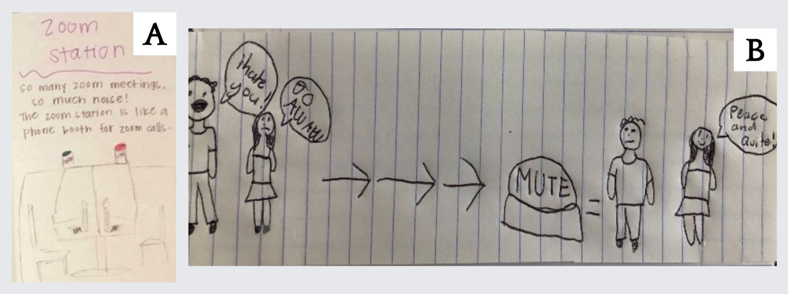
Figure 1: (A) “Zoom Station” Two desks are shown with laptops and glowing lights marked “on” and “off” (P8_A). The drawing is captioned: “So many zoom meetings. So much noise! The zoom station is like a phone booth for zoom calls”. (B) “Shush” (P14_B).
As the study unfolded, parents shared how the initial, iterative adjustments to the pandemic also included finding, discerning, and applying COVID-19 safety guidelines. Parents across Groups A, B, and C referenced not knowing how to safely adapt their family routines (e.g., grocery shopping, working in-person, socializing) to be compatible with COVID-19 safety guidelines and feared contracting the virus as a family. After reflecting on their struggle to incorporate COVID-19 safety into their routines, families designed ideas that would simplify that process. Families also shared how, prior to COVID-19, they relied heavily on community groups—such as sports teams or scouting groups—for social support and connections and that these connections have grown weaker over the pandemic. Their design ideas (shared below) reflect\ desires for community-focused approaches to survival during the pandemic by addressing equity of access to resources like housing and food or empowering communities to track and prevent the spread of COVID.
    - Design Ideas: Personal and Collective COVID-19 Safety
At the onset of the pandemic, facing anxiety about contracting and spreading COVID-19, parents shared ideas of technologies that would ease their public safety concerns. Design ideas primarily addressed safety from COVID-19 transmission while outside the home and social distancing. P10_A is a mother of five children under nine years old and designed a teleportation device that would enable safe movement between home and school. P2_A’s family, who also has a child under age nine, shared a similar idea, the “Safe-T-Bubble", which “is a teleportation device that transports you where you want to go while keeping you enclosed in a bubble to stay safe from the virus” (Figure 2-D). P8_A’s family, with two children under nine, shared two accessories that would make it easier to leave the house while not forgetting important materials like hand sanitizers and masks (Figure 2-A). They shared,
“...inspired by the various safety suits and similar to covid detectors, the new “Vigilant Vest” keeps kids safe when they go back to school! My kiddos are starting day camp (much smaller and cleaner version) on Monday and there is a whole list of new rules and supplies (i.e., hand sanitizer and masks). So, a fashionable multi-purpose vest with many sanitizing pockets is a necessity! The little light on top [can] warn when kids are getting too close to others (6ft warning sound) AND warning when senses covid. The Vigilant Vest keeps the kids safe and allows [them] to return to a somewhat typical routine” (P8_A).
Despite isolation imposed by public safety guidelines, the altruistic spirit of community connection remained. Several of the families’ co-design ideas aligned more toward community-oriented well-being. For example, P6_A’s family shared a technology that could administer a vaccine to all:
“Our son was super ambitious and came up with the COVID Vaccine Delivery Drone. It would actually be a nice partner product with the different COVID detector ideas other people have come up with. He said that he knows some people won’t want to go to doctor’s offices for a while so why not have the vaccine delivered to homes?! Who would administer the vaccine is a different story. Maybe we need a robot for that?” (P6_A).
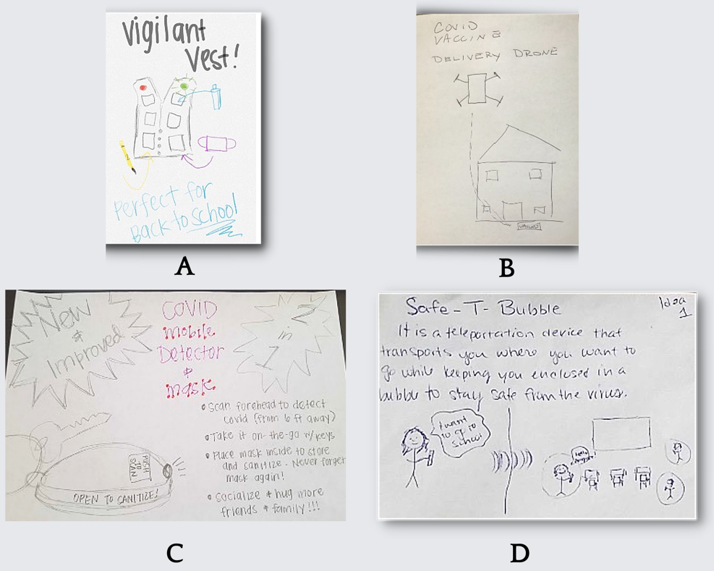
Figure 2: (A) “Vigilant Vest” A vest is shown with multiple pockets to keep school resources, masks, and sanitizing supplies. It is captioned “Perfect for Back to School”. - P8_A. (B) “COVID Vaccine Delivery Drone” A drone is shown flying above a house and delivering a vaccine for COVID-19. - P6_A. (C) “Safe-T-Bubble” (P2_A). (D) “COVID Mobile Detector & Mask” A device is shown attached to a keychain, with the caption: “New & Improved, 2 in 1: COVID Mobile Detector & Mask. Scan forehead to detect COVID (from 6 ft away), take it on-the-go with keys, please mask inside to store and sanitize. Never forget your mask again! Socialize & hug more friends & family!!!” (P8_A).
P4_A’s family, who has two children aged three and six, shared an idea for a COVID-19 community monitor that would visualize social needs related to hunger, housing, and poverty: “What if we had a better idea of what everyone in our community needed or was lacking? Wouldn’t we ALL be better as a result? Our idea is a ‘COVID Community Monitor’ that transmits everyone’s needs to an impartial/unbiased government agency that can get people that help they so desperately need. Everyone’s needs are different, and this would help us meet those diverse needs. Food could be dropped off, medical professionals could visit the sick, therapists could help the lonely, etc.” (P4_A). Similarly, the “WeMunity” idea (Figure 3-A) shared by single mother P15_B, displayed a dashboard to track and support community needs.

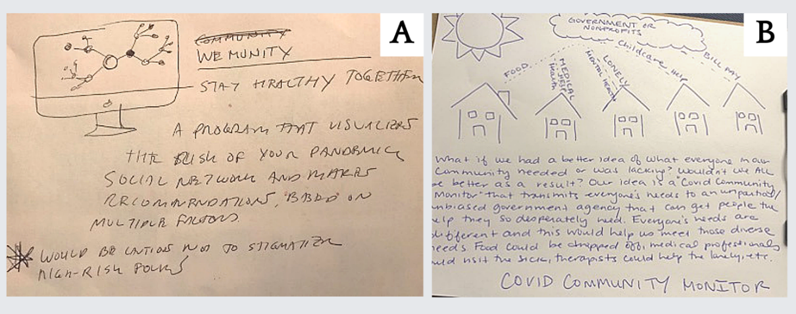
Figure 3: (A) “WeMunity” A computer is shown with a network on the screen. The image is captioned “Stay Healthy Together. A program that visualizes the risk of your pandemic social network and makes recommendations, based on multiple factors. *Would be cautious not to stigmatize high-risk folks” (P15_B). (B) “COVID Community Monitor” (P4_A).
  - Parent as Provider
Parents experienced extreme stressors concerning their role as providers during this study. While most of these stressors are not directly tied to technology, they are an important part of the context for HCI researchers and designers who seek to design, implement, and evaluate family-centered technologies that work in crises, whether those crises are global or family-level. As a critical example, one family participant (P28_Group C) experienced significant difficulties as a low-income parent navigating housing insecurity with three children.
The parent in that household was a single mother to 7-, 8-, and 10-year-old sons and took care of 2 dogs. She worked as a housecleaner and applied for unemployment benefits during the pandemic. While she initially received benefits for three weeks, she became locked out of the online system and could not return to re-certify and continue receiving benefits. Meanwhile, she struggled to support her three children through remote schooling with only one smartphone to share. They also struggled to find strong, accessible WiFi connections. Initially, their cellphone provider offered a free month of data due to COVID, however, this benefit did not last. At the time of our follow-up interview, the mother of P28_Group C was homeless in a hotel with her three sons. Our research team worked with the family to call local shelters to find temporary housing and were not able to secure a spot, due to full capacities.
Participants in our screener survey also shared a diverse set of work-related experiences and concerns, ranging from no changes to their work needs to decreased hours and lay-offs. Across income levels, parents shared that their spouse or themselves worked longer hours than before or changed their hours to fit around childcare needs due to gaps in childcare. One parent shared:
“Wow, it has been truly insane. Because my children (age 6 & 9) are home-schooling all day, I can barely scrape out 4 hours of work per day. I try to fit 8-10hrs of work into those 4 hours, which is incredibly stressful. I'd like to work less, but as an hourly consultant, that means I'd have to sacrifice income. That feels impossible given the economic disaster underway. I fear that these might be the last paid hours for months. It's so hard to know what will come” (Anonymous, screener response)
Parents who remained employed shared fears about their work suffering, decreased productivity, and constant interruptions while attempting to work remotely. Meanwhile, parents with more precarious job positions shared concerns about job insecurity due to funding, furloughs, and needing to take sick leave and vacation days for childcare. Parents who were essential workers—such as those in healthcare, teaching, or social work—shared that burdens arose with longer work hours, mental stress, and exposure to COVID-19. One parent, who is a teacher, shared their evolving role of providing social services needs during the pandemic:
“I am doing lessons online. I am working from home. I work harder and more hours now than I did at school. I worry about my students. I wonder if they are eating. I call in weekly to talk to parents and students. I have taken work and food to students' houses” (Anonymous, screener response).
Parents’ decisions related to work were also influenced by caregiving needs and health concerns. Some screener respondents shared their decisions to leave positions as essential workers due to fears of virus exposure for their immunocompromised households. Parents of children with disabilities expressed increased concerns of the pandemic impacts. One parent who responded to the study screener shared, “I've had to greatly decrease my hours as I try to manage our 3-yr-old and his school/special ed needs. Can't sustain it financially much longer” (Anonymous, screener response). In some of our follow-up interviews, we also heard about emergent caregiving needs, such as a family contracting COVID-19 or taking care of sick in-laws.
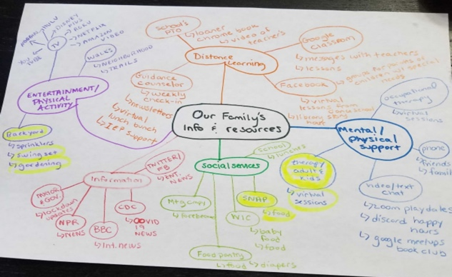
Figure 4: “Family Information and Resource Map” A network of resources is connected back to “Our Family’s Info & Resources”, including: “Social services, mental/physical support, entertainment/physical activity, and distance (P24_C).

For many parents, work opportunities disappeared entirely. For example, in the initial screener responses, parents who were doulas, substitute teachers, wedding photographers, coaches, and daycare providers felt exasperated about their work prospects. One business owner shared that she was able to pivot and, “work from home now as a teacher...family retail business closed.” A seamstress who faced a standstill with clients shared, “I've had no business since - turned to mask making for donation.” For other families, employers offered some support (such as a Walmart employee who referenced their “Associate Critical Needs” fund), while other families referenced reliance on social safety net benefits, such as the stimulus checks shared by the United States government, WIC (Women, Infants, and Children benefits), and food pantry support (see Figure 5). More rural families faced safety concerns due to geographic isolation, as the parent in P24_C from the lower-income group shared that their family had trouble getting food or finding community-based grocery delivery options while in quarantine.
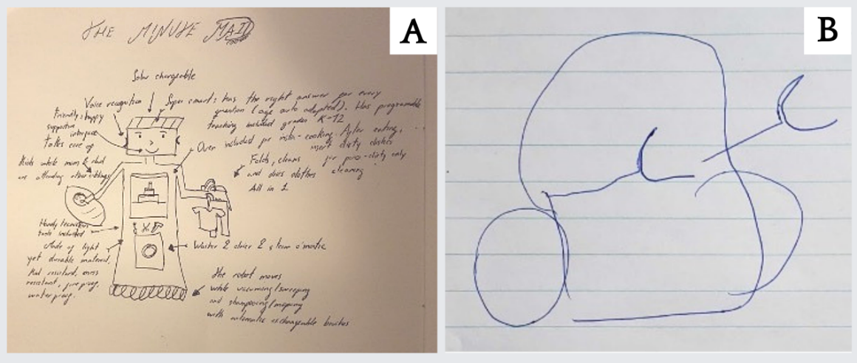
Figure 5: (A) “The Minute Maid” The Minute Maid idea features and descriptions in the picture include: “voice recognition, friendly, happy, and supportive. Takes care of kid while mom and dad are attending to other siblings, handy technician tools included, made of light yet durable material, kid-resistant, mess resistant, fire-proof, water-proof. Super smart: has the right answer for every question (age auto adapted). Has programmable teaching, including grades K-12. Oven included for insta-cooking. After eating, insert dirty dishes. Folds, cleans, and dries clothes all in 1, Washer and dryer for steam’omatic. The robot moves while vacuuming/sweeping and shampooing/mopping with automatic, exchangeable brushes” (P11_A). (B) “Roborganizer” During the co-design activities (Weeks 6-9), P25_C’s family contributed an idea for a robotic organizer who utilizes AI to support home cleanliness and organization. (P25_C).
Two of the single parents who worked in higher-education expressed that they were considering career moves from the nonprofit sector to private sectors for higher pay that would enable them to afford childcare if schools remained closed to in-person instruction. One of the parents had already told her employer that she planned to take Family and Medical Leave (FMLA), a US federal law that allows people to take unpaid leave from work while retaining their insurance, because of the psychological strains from juggling remote learning for her child and work. When asked about what was going well, if anything, a different single parent shared that with the help of her therapist, she carved out self-care time between the hours of 3:00am to 5:00am when no other work or obligations were expected of her.
In two-parent households, people shared how parents negotiated their caregiving and work responsibilities. For example, where one parent was an essential worker, the other parent compromised to take on more childcare responsibilities. Another parent shared a more even distribution of childcare writing in the screener, “My work schedule is spread out across the day, starting around 7:00 am and ending around 10:00 pm. My wife and I split up parts of the day.” In another household, one partner put their career on-hold to provide childcare: one Etsy-selling artist explained that she paused making items to take care of children instead, because her fiancé had increased hours at his job as an essential worker.
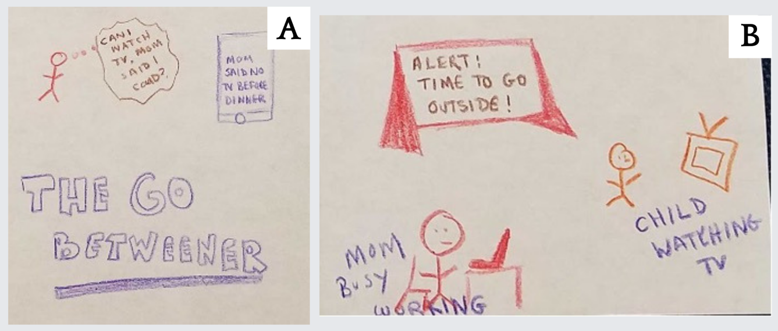
Figure 6: (A) “The Go-Betweener” During the co-design activities (Weeks 6-9), P2_A’s family created a smart device, “The Go Betweener” to support enforcing parents’ decisions in the home. (B) “Decision Station” During the co-design activities (Weeks 6-9), P2_A’s family created a smart device, “The Decision Station” to curate children’s activities while adhering to parents’ rules.
    - Design Ideas: Supporting Provider Household Activities
Basic household maintenance, such as cleaning, grocery-shopping, cooking, and organizing, induced anxiety for families as childcare, school, and work responsibilities piled on. Co-design ideas centered on creating clean and organized spaces in the home, and reducing time spent on labor related to household maintenance, through technology-enabled support with chores. P11_A’s family has four children under nine; they found inspiration from other chore-related designs shared in the group. Their family created “The Minute Maid” (Figure 5-A), which: “...takes on the most time-consuming and at times trivial tasks - especially cooking and cleaning - so you can focus on what's most important; spending quality time with family. We liked the idea of the cuisine computer, dishromantic, and laundry fan. Cooking and cleaning up after a large family consumes so much time, and with everyone home during COVID this has been especially apparent” (P11_A).
The next idea, shared by P25_C’s family (from the lower-income group), was the Robo-organizer, which: “runs through the home similar to a Roomba, but it picks up large objects. It’s AI learn(s) where you keep different types of objects. It sorts them and puts them away correctly. It keeps your house organized so you can focus on work or school.”
    - Design Ideas: Automating Parent-Child Communication and Parent-Parent Coordination
Two-parent households also expressed tensions about coordinating shared childcare decision-making during the co-design sessions of the study. P2_A’s family shared an automated design that would keep track of parents’ rules and answers to children to reduce daily distractions. The same family shared another idea of a technology that reiterates a day’s activities and expectations in a scheduled manner to support parenting coordination and child interactions, “The Go-Betweener.” They describe it as:
“Logs answers to questions/rules established by one parent. When a parent asks the other parent the same question, it lets you know a rule was already created and what it was. Gone are the days of one parent saying no and the other parent not knowing and saying yes. Easily add as an app on your smartphone or watch” (P2_A).
Similarly, the “Decision Station” reinforces decisions that parents have made by repeating those decisions on behalf of parents. The family described it as: “Make decisions on behalf of the parents and answers certain questions. Avoid answering the same thing over and over. For example: can I have a soda? Reiterates the schedule, activity, or structure should be happening, for ex: "Can I go outside?" "Yes, but stay in the yard!" (P2_A).
Other households embraced existing technologies, such as Amazon’s virtual assistant Alexa, for question-answering and information collection. While some parents reflected on the annoyance of children controlling what is shared through Alexa, others reflected on the technology’s affordances for keeping children entertained and informed. Families saw tremendous potential to leverage AI assistants like Alexa for keeping children engaged, supporting homework assignments, and staying engaged. As a mother of two children aged five and eight (P8_A) shared:
“I've seen the meme circulating about "Alexa homeschool the children" and it's made me laugh. But also I feel Alexa is such a great tool right now. She [is] so reliable. She has all the answers and [she’s] clear when she doesn't understand me. My kids ask her everyday about the weather. They engage in her jokes and random facts. It's almost like having another adult in the house. As I was [in] the bathroom once my daughter asked me how to spell something and I said, "go ask Alexa." [Alexa] now knows all of our voices. She keeps a grocery list for me, which the kids will add to hourly. It's very convenient having her around! I am grateful for her expertise!” (P8_A).
  - Parent as School Administrator
During the pandemic, parents assumed new roles as the primary facilitator of their children’s learning experiences and encountered both barriers and benefits to using various technologies to support them in this role. To highlight the new challenges introduced by this role, we describe one single mother’s (P12_B) tribulations with devices to support her 9-year-old child’s transition to remote learning.
From the start of the COVID-19 pandemic, P12_B worked from her bedroom, and her daughter attended virtual, synchronous classes 5 days a week. As the only adult in the household, P12_B was the primary contact for frequent breakdowns in technology function—providing mental and emotional support for her daughter—and facilitating her daughter’s attendance in classes and completing classwork. P12_B described her family’s transition to remote learning as “awful in the beginning”, as they had to borrow laptops from P12_B’s job. The first two laptops were not compatible with Zoom and the software required by her daughter’s school. Once P12_B borrowed a laptop from her child’s school, it worked, although restrictions on the laptop prevented her daughter from attending dance class. P12_B changed her work schedule to accommodate her daughter using the work laptop for dance class. Through this transition, P12_B had to compromise her stance on screen time and struggled to find ways to keep her daughter engaged socially and to take regular breaks for her mental health. As schools begin surveying parents about phased approaches to in-person learning, P12_B balanced her fears from a horrific remote learning experience with not knowing the right choices for mediating tech use her daughter.
Like the single mother in family P12_B, other parents expressed how they provided support and guidance for tasks like attending class, submitting homework, communicating classroom and learning experiences, and providing tech support for virtual learning materials. At least one parent from Groups A, B, and C referenced not having a single, cross-platform location to store relevant logins, links, and assignment due dates. Two families with more than one child cited organizing between different schools (e.g., middle school vs. high school) as they used different software and contacted parents via different communication mechanisms, leading to miscommunication and frustration for both parents and teachers. Two families with children under 12 shared the experience that their child’s teachers all used different software for virtual learning activities, leading to confusion and ill-managed schedules:
“The portal is fairly useful. Although the way different teachers are using it (i.e. where they are posting assignments, messages) varies which makes it a bit of a chore to keep up with weekly assignments” (mother of two children aged three and a half and twelve, P32_A).

“I just wish the grades in [there] would compute like the grades in IO classroom because it’s confusing for the kids when I tell them to disregard google classroom final grade but the grade for assignment is correct. I know that sounds weird to them because it sounds weird to me” (mother of one child aged three and from a low-income background, P23_C).
In these instances, children were unable to manage their virtual learning experience independently, unlike how they might at school (e.g., knowing where their classes are located, coming to class with needed materials, or adhering to classroom expectations). One single parent shard that their children were expected to know how to use new virtual learning software without thorough introductions, and their schools expected that parents could support them with troubleshooting issues (P15_B). In their diary study response, two parents described their children as being too young or inexperienced with technology to self-manage their classes and assignments (P14_B; two children under 12) or troubleshoot tech problems on their own (P29_C; has a 3-year-old). One parent of five children (P2_A) described the unrealistic expectation that their middle schooler could manage their virtual learning materials without their parent’s help:
“Our middle schooler's work is pass/fail. We find it very difficult to help them stay organized because they have 6 plus teachers and each teacher uses different platforms and multiple websites. It is like my child is supposed to manage this like a college student when they're only 13. I told the guidance counsellor if I can't manage simply reading all the different emails from the teachers, how am I supposed to expect my kid to stay on top of everything. I'd rather my child do what's best for them mentally than worry about school right now anyway” (P2_A).
Two parents with children aged 10-12 referenced helping their children attend class as a new responsibility (P9_A; P14_B). Despite the expectation that high school students might manage their work more independently, parents of children in elementary, middle, and high school explained that their children were unable to login to virtual classrooms independently, as their children could not keep track of multiple logins, links, or calendars (P11_A; P26_C; P8_A) or encountered technical issues they could not problem solve (P6_A; P26_C): “Zoom changed the rules, and now only [the] host can share the screen. It made it hard for the actual ‘host parent’ to share his screen with the kids when my son and I were running a little late. So, the meeting was delayed by 5-7 minutes” (P29_C; has a 3-year-old). “Sometimes links or websites are unreachable which makes completing the given assignment more difficult” (P19_B; age of child not provided).
Beyond logging in, parents also had to monitor their children during their classes due to varying engagement needs (e.g., children who are shy, young, or have special needs) that the teacher could not manage virtually (P26_C; P27_C; P28_C). Between facilitating class attendance and homework submission, one single parent from referenced their need to communicate and enforce classroom and learning expectations to their child to reinforce the teacher’s expectations (P15_B; age of child not provided). Although their teachers provided outlines for classroom and learning expectations, parents often needed to re-explain those expectations to their children (P4_A; has two children aged 3 and 9). During class and homework sessions, three parents of children under age 8 had to reinforce classroom behavior and learning expectations, such as helping their child stay attentive and in their seat (P27_C; P4_A; P8_A), which took time away from other tasks for which parents were responsible (P27_C; has a 5-year-old).
“It's great to have [my child] see her classmates and teacher, with the speaker mode enlarging their screen to better focus. The only issue is the overlap of voices, especially with kids fidgeting and talking all at the same time. This caused multiple times throughout the past month when the teacher wouldn't hear what my already shy child tried hard to say. It's a minor convenience but especially affected her experience at the beginning of the transition, she refused to participate and would find excuses to leave her seat” (P25_C; has three children under 6 years old).
Parents across the three groups discussed homework submission as another time-consuming task. Two parents experienced technical difficulties with homework submission interfaces (P11_A; P6_A) and two parents struggled to keep track of homework submission policies that differed between classes (P11_A; P13_B). One parent from the lower-income group described virtual homework as ineffective for her child, and consuming time and resources for their family:
“I don’t think Google Classroom is right for preschool. I don’t think that having my child do work on a tablet is going to help him gain the proper prerequisite skills, so I print everything so it by hand and then upload, but [it is] creating a lot of extra work. Sigh.” (P23_C; has a 3-year-old).
    - Parent’s Role as Technology Support
Broadly, parents across all groups assumed a technology support role for their children by troubleshooting common hardware issues for their children like internet connection and device problems (P30_C; P8_A). One parent of two children under 10 years old had issues managing device availability for their children’s classes or the parent’s work needs (P1_A). One parent from the lower-income group discussed their need to monitor internet usage more closely to ensure that their internet plan would support demands from their work computer and their child’s school computer: "I wish zoom wasn’t such a battery and data drain I’ve had to increase my home internet speed just to be able to work.” (P23_C). One parent of three children (aged 2, 13, and 17, mentioned troubleshooting the new platforms used for virtual learning across grade levels, like video conferencing software freezing (P3_A). One parent from the lower-resource group, who has three children, experienced confusion when navigating new platforms and spent extensive time solving those issues (P28_C). One parent of two children under 6 shared, “Also, being referred and asked to use all sorts of new apps with different logins, which is starting to feel overwhelming learning how to use too many new platforms/apps. A limited number would be nice” (P4_A).
P14_B, a single parent of two children under 12, experienced problems uploading their child’s virtual assignments, while another parent from the low-income group spent time troubleshooting broken links with teachers and school administrators (P26_C). Parents also lamented on decreased amount and quality of social interactions than what schools typically provided. This was evident in several of the co-designed ideas shared, where technologies like virtual reality, augmented reality, or holograms can support deeper social bonding experiences (Figure 8-B).
    - Design Ideas: Learning Solutions
Families ideated different technology solutions intended to remedy their struggles with learning technologies, device and connection issues (Figure 7), and lack of social engagement with friends from educational contexts. One family with three children aged 2, 13, and 17 (P3_A) presented two digital solutions to classroom engagement needs through a gamified school experience to promote more engagement, using augmented and virtual reality technologies to safely replicate real-life experiences at school (Figure 8-A/B). They describe their first contribution, “Cerebro Masters” as “an online gaming platform that is connected to teachers’ gradebooks. Kids gain points for class participation, attendance, and grades. Points can then be used to level up characters, buy game equipment and customizations for avatars, and more. This game reinforces good grades and class participation while allowing kids to have fun in a virtual environment. The game can also have different levels for different grades and allow kids to fight bosses or challenge one another in duels as additional ways to gain game points” (Figure 8-A; P3_A).
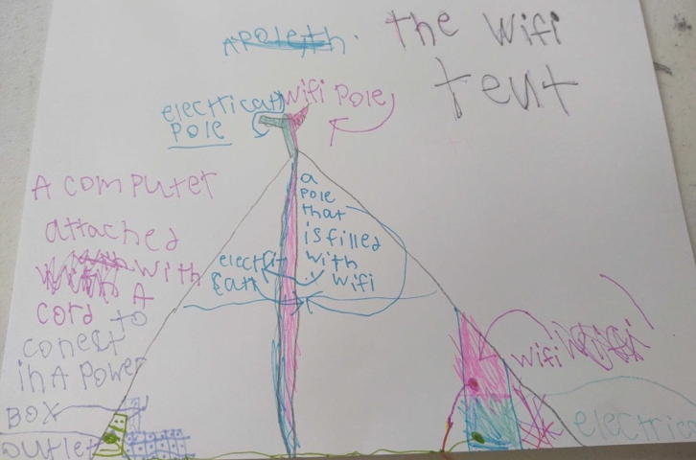
Figure 7: “The Wifi Tent” Parent-generated description: “Take learning anywhere with the fully portable WiFi tent. WiFi tents come in a variety of sizes for any family. It comes with built-in fold down desks for working, solar powered electric system with battery backup, and WiFi booster so you can get the best signal anywhere. It also has Bluetooth for wireless connection and file sharing. The optional mega backup battery connection center will allow you to connect more or larger devices such as a mini fridge for snacks” (P21_C).

Their second solution to promote more engagement, “Virtual School Oculus (VSO)”, provides “An online augmented reality platform where teachers and students can interact without having to be physically in front of each other. Teachers and students will need to create their own avatars and logins to enter VSO. Each teacher and student will be equipped with a helmet that projects the classroom and provides them with speakers and microphones. To move their avatars, teachers and students will use controllers, and the VSO environment itself can be modified based off a learning topic (e.g., a Greek mythology environment)”. P3_A‘s family described a remote-controlled android, the “C-Human”, which would attend school in your place (Figure 8-D), to replicate the physical experience of attending school without risking COVID-19 exposure. Their description summarizes the functionalities of the “C-Human”: “Want to go to school but afraid of catching COVID-19? That’s where the C-Human comes in. The C-Human is a computer android that goes to school for you and stays at school. You, the actual student stays at home, but you can control your C-Human using electronic gloves and socks that are attached to a computer and sends electrical waves to the android and controls it. You are able to interact with others in your class through their androids. At the end of the day you click on the icon of an outlet on the C-Human to make it recharge itself for the next day”. Other contributions, like P21_C’s “Smarty Cat”, utilizes the familiarity of stuffed animals for more engaging at-home learning experiences. P9_A's family, who has a 10-year-old, contributed a paired system, where one drawing illustrates a parent interface intended to monitor their children’s progress remotely and the second drawing portrays the child’s interface that supports them to seamlessly submit their assignments while tracking their progress (Figure 8-C and Figure 8-F).
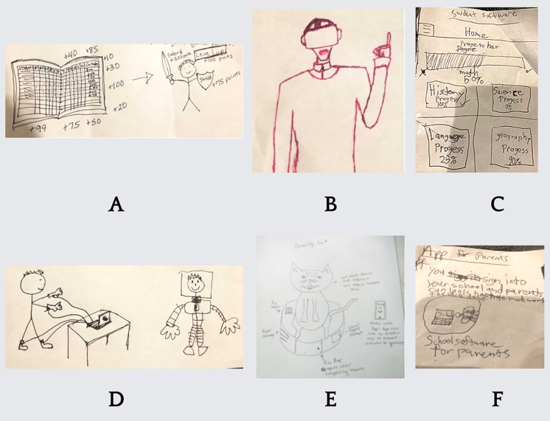
Figure 8: (A) “Cerebro Masters” A gradebook is shown with added points floating around it. An arrow points from the gradebook to a student with a sword and shield, whose gear is leveled up by the grade points. (P3_A). (B) “Virtual School Oculus” A student is drawn using a virtual reality headset (P3_A). (C): The title “Student Software” is written across the top of the page. There is a sub-header, “Home”, and has a button for a longer menu (P9_A). (D) “C-Human” A student is drawn controlling a robot, using shoes and gloves connected to a computer by wires. The robot’s screen displays the student’s face (P3_A). (E) “Smarty Cat” Parent-generated description: “Smarty Cat: Do you need a way to keep your young children interested in learning at home? Look no further than Smarty Cat. Smarty Cat is a soft plushy friend that can stream your child's teacher's voice, teach your custom lesson plans, or use a plan from our extensive library. In addition to the Animatronic Smarty Cat Plush, you also get the base unit which is a charger for Smarty Cat, a storage case, and prize box. EZ” (P21_C).
“So, we look up nature videos of what interests [her child] and choose a reputable source that is somewhat kid-friendly (though it doesn't have to be made for kids specifically). I just created a YouTube kids account for [her child], but we haven't really used it. Usually, we're logged in under my name. The problems with YouTube are ads...directed towards me...and things [her child] doesn't need to see...or the sidebar of [automatically playing] recommendations can distract [her child and] keep her hooked longer than I'd like or might be something I'd rather she not watch. I'm trying to teach her that tech is a tool and therefore [her child] wanting to dig more deeply into a topic that interests her is something I support. Though the internet is so open and unprotected, but [I want] to support and show interest. Sometimes we watch a program on mute if the music or narration is too intense/annoying, especially if we look something up near bedtime. The other problem is I don't use the YouTube app, so sometimes when I open a browser window on my laptop to search for a video, she sees all that junk in Google search results like news stories with alarming images, etc.”
To fill the gaps left by schooling content, parents sought out supplementary learning materials, such as YouTube Kids, to provide stimulation and meet academic goals. Parents across groups shared expectations for newly acquired technology, including affordability, ease of use for children, and feedback loops for learning (such if a child is learning well or making errors). For example, in the diary study from Week 2 of the study, parents reflected on positive experiences with tools like YouTube Kids, ABCMouse, Alexa, Scratch, Quizlet, Quick Math Jr, PBS Kids, Noggin, Osmo, Khan Academy, Kahoot, and RazKids. Parents highly rated these technologies as enriching, fun, full of variety, and accessible for children. For instance, software such as Raz Kids and Epic made reading more interactive for children through assistance like highlighting words that were being read as well as through fun visuals. Nine parents in the diary study reflected on positive experiences with Khan Academy, sharing that it required minimal help from parents, the tone was fun but not overwhelming, and the ability to customize the levels of challenge helped kids stay encouraged. Parents also appreciated free content and shorter lessons that positively supported feelings of incremental progress.
One parent reflected on her experiences in the initial transition to remote learning with the need to find meaningful curricula. Her searching efforts were filled with doubt, since she did not know her children’s grade-based learning goals. She shared,
“It takes a lot of time to find good (learning) content and I have 4 kids. After a bunch of hours of reading curriculum online, I was able to find materials. I wish Google (search) would prioritize quality of content, but of course that's too much to ask...It would be nice if there was some sort of filter - like for grade level or price. Many of the worksheets you had to print too. So, I ran out of ink and then I couldn't buy ink” (P11_A; has four children under nine).
In contrast, the reported negative experiences with learning technologies included Zoom, the Seesaw app, Google Classroom, and Microsoft Teams. Many of the negative reflections related confusion with wayfinding within the technologies and the parental supervision required to troubleshoot issues. For example, the Seesaw app is described as a digital student portfolio that enables parents to monitor school activities. In some contexts, teachers are using Seesaw as their primary learning management system (LMS). A mother of four children under nine (P11_A) shared a confusing experience from unclear chronology and level of actionability through the app saying: “It doesn't allow for clear differentiation of tasks or subjects. It is more like a feed. One post after another without any order other than the chronological order in which it was posted”.
In addition to traditional learning technologies, parents shared positive experiences with open-ended and creative tools, related to their contributions to positive development and non-addictive qualities. Amid anxiety about increased screen-time, these meaningful play activities brought some reassurance and comfort to families. In reflecting on tools like Scratch, Sampulator, or Magic Sketchpad, P15_B recognized the effects on her child, sharing, “... they seem to have a positive impact on her vs. making her wired or hooking her in.” Parents also enjoyed Minecraft and aligned with sentiments like: “It is creative, engaging, and they learn lessons from it” (P2_A). When describing her son’s experience with the ArtRage app on iPad, P30_C said, “It was wonderful to watch my son be creative on a screen rather than just gaming.”
To combat their concerns about screen time, many parents curated hands-on activities with kids—including gardening, biking, or arts and crafts—when time and space allowed, as expressed through a dozen comments on the Slack groups. As seen in examples by P15_B and P1_A in the following section, families reflected these desires for a combination of physical and social engagement, which also addresses more of a balanced relationship with technology.
    - Managing Digital Media
Prior to the pandemic, the American Academy of Pediatrics (AAP) recommended screen-time guidelines that included upper limits of one hour daily for preschoolers, one-and-a-half hours a day for elementary school students, and two hours for those in middle school. ParentsTogether, a non-profit that supports families, found that screen time during the pandemic increased 500% for nearly half of the families that responded, raising concern about technology use [69]. While there are no clinically recommended time-limits, health practitioners emphasize balancing screen-time with quality family time. In this study, while many parents enjoyed exploring supplementary learning materials, this also came at an expressed cost of concerns about age-appropriate content, addiction, privacy, overstimulation, and screen-time.
In the diary study in Week 2, parents expressed a desire for more control and moderation of age-appropriate content as well as features that enable content filters, remove autoplay, and disable photos or videos on platforms like WhatsApp and Facebook Messenger (P21_C, P15_B, P27_C). For example, P27_C suggested, “I wish we can set a timer on how long it lasts, where it indicates to the kid something like the old days ‘the channel will stop airing in 5 minutes’ to end the power struggle of autoplay.” Parents also shared emotional concerns about digital safety. P30_C explains, “I have to be vigilant about the Xbox so people we don’t know can’t try to chat with my son, which is stressful.” Another parent (P3_A) shared that despite her moderation efforts, her 12-year-old son was able to bypass an existing parental control app by hacking the settings.
In their current state, parental controls are not well-integrated into school-sanctioned technologies and norms. For example, schools often lend out Chromebooks that enable parental controls, yet teachers may assign content with YouTube links, which are blocked by those controls. As P32_A explains his frustrations:
“I’ve set up Google’s family link parental controls on my son’s Chromebook but there are unintended consequences. He can’t access YouTube (he’s 12 until July) which he needs for class assignments, and he can’t access the microphone to record responses for his Spanish and music teachers. I’ve tried making adjustments in the control settings, looking up tips online, with no luck. Quite frustrating. We’ve let him use the family MacBook Air to submit the assignments, but I’d like to figure out how to give him the appropriate access on his own laptop” (P32_A).
    - Design Ideas: Supporting Media Curation and Mediation
The families designed solutions to curate meaningful media activities through gamified learning and extracurricular platforms, digitally enabled physical play, and curation tools. P10_A has five children under nine and shared an idea from the co-design prompt that enabled better alignment of “in-school” content with “at-home” supplementary learning:
"This item combines an augmented reality school experience along with an at-home supplementary robot for continued learning, and it includes the cerebro masters (a previous gamified learning idea) as an online gaming rewards system to encourage motivation to learn. A child/teacher can virtually attend school while, at the same time, the avatar will research more ideas for the child to use at home to supplement the lessons. When lessons are completed, the child is rewarded with a VR gaming experience. Extra points are earned by completing supplemental materials as well” (P10_A).
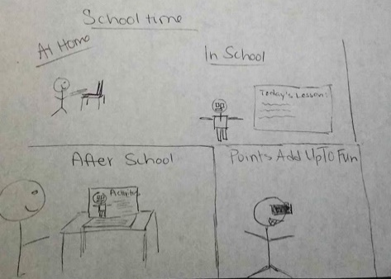
Figure 9: “Virtual Cerebral Masters” A student is shown using their computer, represented by a robot at school. After school, the student completes their lessons and is rewarded with a virtual reality gaming experience. The image is captioned: “At home, In school, After School, and Points Add Up To Fun” (P10_A).

They also offered ideas to counter their concerns about too much screen time for children by offering physical, creative, and social alternatives to screen time. P15_B’s family designed a platform for sharing ideas and resources for safer ways for young children to play with friends and extended family—particularly older adults. They wrote that this platform would include content such as physically distanced playtime ideas, making mask-wearing more fun for kids, hand washing songs, safer ways to hug for when the children cannot resist, and facts about social/emotional wellbeing and its impact on the immune system.
Meanwhile, the “Energy Zapper”, shared by one family (P1_A), provided alternative entertainment through exercise and customizable physical challenges by “helping tire kids out when it is too hot or stormy outside, being reconfigurable, and charging the TV through exercise.” Similarly, the Screen Sorcerer, created by P8_A’s family, aimed to address an anxiety of too much screen-time. The tool not only prompts breaks and non-screen-based activities in a timely manner, but it also encourages children to “earn” their screen-time. They described the tool: “The Screen Sorcerer monitors child screen time. It will automatically lock and force them to do other activities after certain time. Children can choose activities to unlock the next YouTube video or episode. For example, count to 100 or read a book aloud for 10 minutes. Children get to choose activities and get a balance of activities throughout their day” (P8_A).
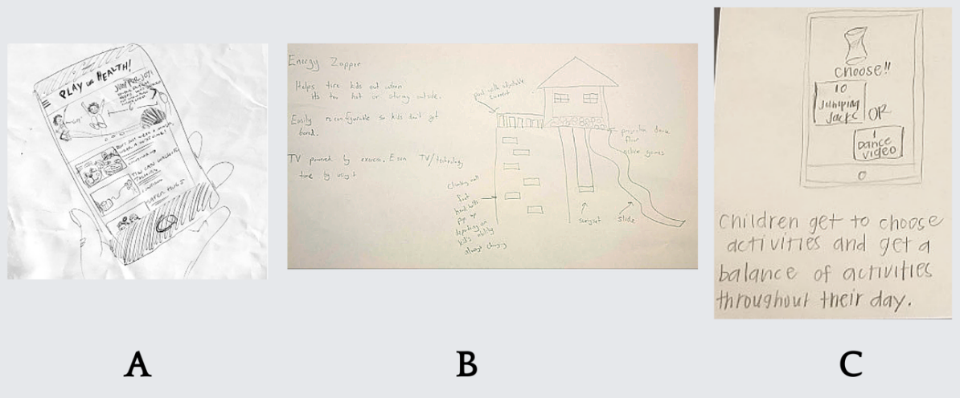
Figure 10: (A) “Play For Health: Creating Space for Connection” A smartphone app is shown with different activities related to health, COVID-19 safety, and social connection opportunities. - P15_B. (B) “Energy Zapper” An at-home playground is shown with captions: “Helps tire kids out when it’s too hot or stormy outside. Easily reconfigurable so kids don’t get bored. TV powered by exercise. Earn TV/technology time by using it. Pool with adjustable current, climbing wall, foot and hand holds pop up depending on kid’s ability- always changing, swing set, slide, projection dance floor active games” (P1_A). (C) “Screen Sorcerer” A smartphone is shown with an hourglass on the screen, and the prompt “Choose”, to which there are two responses: “10 jumping jacks” or “1 dance video”. Parent-generated description: “The screen sorcerer monitors child screen time. It will automatically lock and force them to do other activities after certain time. Children can choose activity to unlock next YouTube video or episode. For example, count to 100 or read a book aloud for 10 minutes. Children get to choose activities and get a balance of activities throughout their day” (P8_A).
- DISCUSSION: TENSIONS IN DESIGNING FOR FAMILIES DURING A PANDEMIC
As we write this (April 2021), families continue to experience multiple, simultaneous pressures resulting from the COVID-19 pandemic and resulting shifts in how people work, learn, and play. Our results highlight the different stresses experienced by parents throughout their changing demands at work, as providers, and in facilitating the education, entertainment, and wellbeing of their children. Parents turned to online media and other technologies to help meet these demands, but these in turn led to stresses about increasing the amount of screen time they and their children experience, perceived consequences that might have for their children, and time and resource demands on parents.
The pandemic exposed many gaps in adapting remote learning to family needs, infrastructures for coordinating and communicating about learning, family-friendly technology design features, and safety net support. Considering parents’ experiences of being overwhelmed, we encourage designers and education technology implementers to explore child-friendly user experience design to support more autonomy, consistency, and clarity in children’s technology experiences, especially with remote learning. We suggest that learning communities (including decision-makers like school administrators and teachers) and family technology designers for children in preschool through 8th grade intentionally and holistically attune to parent and child needs when making decisions about learning technologies.
The CSCW research community and family technology designers can make meaningful improvements to family-centered technology for remote or hybrid learning and family well-being. Families in our study revealed contradictory learning needs across the groups. Rather than emphasizing technological solutions for remote or hybrid learning, communities can emphasize shared conversations to surface, prioritize, and compare practical and social needs for schooling. Based on these diverse needs, preferences, and desires expressed by families in our study, we present five key design tensions from the findings and corresponding suggestions for design (see Table 3). “Design tensions” is a framework that offers opportunities to reflect on the suitability and relevance of design decisions in their unique contexts [67].
5.1 Considering Structure vs. Flexibility in Remote Learning
Parental mediation theory explains the different strategies that parents utilize to maximize the benefits and minimize the risks of technologies for children [40]. Jiow et al. further describe parental mediation as form of larger strategies (active, restrictive, and co-viewing) through specific gatekeeping, discursive, investigative, and diversionary activities [50]. They describe parents as having diverse motivations behind these specific mediation practices. As such, families have different purposes, situational circumstances, child behaviors and personalities, and lifestyles around learning and technology that need considerations.
Our findings are consistent with prior work showing that families oscillate between needing structure and flexibility in learning environments and that developing and planning child learning needs across home and school needs to be done collaboratively with parents, students, and teachers [50]. However, we found that the urgency of the COVID-19 pandemic demanded more emergency planning and flexible options to meet different families’ needs. While some parents in our study craved more structure for student success, others preferred minimal structure to create schedules that adapt to their specific family needs. For example, the mother in the P28_C family had one smartphone for three children to take turns using for remote schooling, with limited WiFi access. As such, coordination challenges are compounded in families with multiple children or other family members in the home who may all need to share a limited set of devices for their work, school, and play. Similarly, with different parents and caregiving demands, coordinating device-use for studying and turning in homework can be an additional source of stress. Alternatively, other parents shared the experience of extra stress from needing to coordinate learning schedules.
Since there are no one-size-fits-all solutions, we suggest that pedagogical decision-makers (such as school administrators) accommodate the full spectrum of family preferences, ranging from minimally structured school days to many possible interaction points with teachers and peers. These kinds of accommodations from structured to flexible may fit in the multiplicity of ways in which parents already mediate their children’s technology usage through multiple strategies [40]. For example, schools might strike a balance by offering consistent course times and office hours for students who can thrive in those circumstances while developing flexible options for other families, such as recorded classes for asynchronous participation, offer flexible due dates, extra attention for kids with Individualized Education Programs (IEP), and multiple scheduling possibilities for connecting with teachers. If developed so that any individual teacher must only manage either synchronous courses or asynchronous courses, this potentially would better support teachers who may also be working to manage their own childcare or family concerns.
The tension between structure and flexibility also appeared in our follow-up interviews when we asked participants about their concerns and desires for Fall 2020 school plans. Families described feelings about school as a lose-lose situation. On one hand, many parents expressed a concern for safety as well as a desire for children to experience more social connection and learning support. On the other hand, parents described how working (whether as an essential worker or remote worker) while supervising and facilitating remote school and learning activities was not sustainable in the long run. Throughout the co-design activities within this study, three single-parent households (P14_B, P15_B, P17_B) designed open-air school concepts that would enable children to safely attend school outdoors that would enable maintaining a structured school day. These ideas contrast with comments shared by families that would prefer more asynchronous learning at home due to safety concerns.
While there is a desire and pressure for families to continue meeting standard academic progress, it creates pressure amidst competing work needs, schooling, and staying healthy. Recognizing the pandemic experience as a collective trauma can ease the expectations of “normal” classroom engagement and learning progress. When reflecting on what advice she wishes she would have given herself, a single mother (P33_B) shared, “I’d remind myself that imaginative play and life skills like cooking, cleaning, budgeting, organizing are learning as well.” In the absence of traditional schooling, the pandemic expands opportunities for other kinds of learning exchanges related to life skills, cultural assets, and community literacies [27].
  - Child Autonomy vs. Parental Supervision in Online Learning Contexts
Parents across groups A, B, and C experienced tensions between children using technology independently and safety that parent-led mediation affords. These tensions created breakdowns and unintended consequences for online learning, causing further disruptions in learning. For example, parental controls supported closer monitoring of children’s online activities, but they also blocked access to critical content, such as materials shared by teachers on sites like YouTube.
These findings are consistent with prior work documenting families’ competing desires to monitor children’s digital behavior and to give children the freedom to navigate technologies autonomously [21, 39, 40]. Prior work in HCI and IDC has sought to support families in achieving these seemingly incompatible goals through design. For example, “Circle of Trust” [26] is a novel parental control system that gives parents sufficient oversight to require children connect only with loved ones (and not strangers) online, but gives children autonomous control over their messaging with these trusted individuals. "Coco's Videos" supports children in autonomously choosing YouTube-style videos to play, but nudges them to reflect on their choices and self-regulate rather than endlessly autoplaying additional content [32]. These and other innovations seek to guide children toward usage patterns that align with well-being, while simultaneously treating their autonomy as a first-class design consideration.
Our findings suggest such an approach would support families’ values in the context of online learning as well. Prior work shows both that families struggle to negotiate boundaries on technology use [19], but also that enabling child autonomy in technology can build efficacy and confidence for children [32, 34]. We found that both considerations were of great importance to parents who wanted children to be able to navigate their online school day more easily and simultaneously worried about their children’s long hours confined to the screen, digital distracting from off-topic experiences, and access to age-inappropriate content. Nonetheless, families contributed multiple, child-led exploratory digital spaces such as VR museum experiences, child-led VR classrooms (with reading nooks, math puzzles, PE/dance break-out rooms, etc. or with different virtual real-world environments’), and wearables for making art (P1_A, P21_C, P27_C, P29_C). Families’ design ideas suggest designers can help resolve this tension with integrated interface support for taking breaks, making connections between digital activities and offline life, engaging with teacher-selected content, and other ways of holistically considering the role of technology in children’s lives. Future education technology designs can offer transparency into which features each stakeholder (such as parents, teachers, and students) have access and should continue to explore ways to support autonomy while managing parents’ greatest anxieties.
  - Designing Technology vs. Curating Existing Resources
Parental mediation theory, as expanded by Yu et al., includes the frames of creative mediations (supporting children’s learning and explorative creativity), preparative mediation (vetting and curating content), and administrative mediation (sharing and supervising media use) [72]. Parents in our study often took on the administrative mediation role in filling gaps between school resources and remote learning during the initial phases of the pandemic. As such, many challenges families described during this study were not necessarily technology-related but rooted in the labor of curating appropriate content for their children to consume and learn from. Inefficiencies, confusion, and being overwhelmed may have occurred for parents due to pedagogical and organizational issues and their intersections with technology choices and configurations.
For instance, families with multiple children—and consequently multiple teachers or even multiple school systems—may encounter overwhelming learning circumstances that result from a series of choices that seemed reasonable in the context of any one class or any one school system, but that, experienced together, are unmanageable. Teachers face similar problems in choosing among, and then using, the various available tools to support their teaching. While it would be tempting to suggest a single, integrated educational platform that could bring a harmonious experience across these disparate experiences, such a tool is likely infeasible or even detrimental, as different pedagogies and students at different developmental stages may all need different tools.
Initiatives like Learning Tools Integration (LTI) promise to connect some of these tools, making moving between the various tools easier for both educators and students [62]. However, this can still present overwhelming choice for both teachers and parents as they assemble Rube Goldberg-like workflows to support the desired learning experience. Here, we believe there is an opportunity for education technology designers and researchers to work with teachers, parents, and children to recommend parsimonious bundles of tools that offer the needed services, reducing what technologies they need to learn before they can learn. We encourage designers to consider the tools to further bridge at-school and at-home learning. For example, families shared robots and toys that offered supplementary learning through personalized content curation and mimicking teachers’ styles of educating to engage children (P10_A, P21_C). Collaborations between designers and end-users can create space for teachers, parents, and children to share their experiences configuring complicated technologies to work alongside familiar learning tools and routines. More research is needed on just how to best recommend such packages of tools, as well as when needs are best-served for new tool development.
  - Parent-as-Teacher Development and Potential for Design Support
The unprecedented times of the pandemic have revealed urgent needs to design onboarding experiences that meet the needs of teachers, parents, and caregivers, who can be key contributors to an effective educational experience. In this discussion, we draw upon existing research on teacher-focused technology training [70], classroom management, informal technology support in the home [54], and homeschooling, highlighting opportunities for innovation in parent- and child-use technologies for virtual learning.
Prior work in child-centered computing often posits that young children cannot troubleshoot technology issues [56]. Researchers in education have also demonstrated that young children struggle to self-direct their learning experiences [22] without guiding environments and seek guidance from teachers (at school) or parents (at home). Unfortunately, the parents in all groups involved in this study expressed that they were unprepared to take on these responsibilities (P23_C, P12_B, P2_A), especially alongside shifts in at-home family life and work life, like job insecurity, reduced access to necessary childcare services, or in instances where parents are not primary caregivers. Our findings demonstrate that parents are now taking on responsibilities usually reserved for teachers: monitoring their child’s engagement during class, tracking school-day assignments, and troubleshooting virtual classroom materials. Worse, the technologies that parents and children used to participate in virtual learning caused major disruptions in the home and burdened parents alongside their shifting at-home roles.
Teachers are trained extensively in classroom management strategies and often are trained using new technologies for their classroom [57], though training may vary depending on the age of the children they teach. These training sessions equip teachers with strategies to ensure that their students have effective learning experiences. While teachers organize assignments and hold online classes, parents manage their child’s engagement (P26_C; P27_C) and troubleshoot technology problems (P30_C; P8_A). Most parents, apart from those already involved in homeschooling prior to the pandemic, did not experience training sessions and are not prepared to solve engagement or technology issues (P28_C, P26_C). These issues take considerable time, energy, and resources from the parent, distracting from existing responsibilities of parenting and employment (P27_C). This daunting role has worsened the transition into shelter-in-place restrictions for families (P24_C). It is not surprising that families shared ideas co-design ideas like, “EZ WebSchool” (P21_C), which is an online remote learning platform where students and parents can access all learning content, assignments, and meetings with teachers asynchronously and at their own pace so that they can better manage competing needs at home and resulting distractions.
Schools and technology designers might partner to provide parents with onboarding modules or support guides with evidence-based strategies for how they may keep their children engaged during class and homework sessions and support learning outside of classes. Prior research has explored informal technology support in the home, though not within the context of interfaces for comprehensive virtual learning experiences [54]. Researchers and designers might reference this work to develop guides for families integrating virtual learning materials into their at-home routines, to reduce extensive time detracting from existing parenting responsibilities. Educational technology designers may also observe this opportunity to design more child-friendly interfaces that allow children to self-monitor their engagement during class, independently troubleshoot problems they encounter, and manage their school resources in-line with their usual responsibility for in-person classes.
There is an opportunity for technology innovation to support families involved in at-home virtual learning. Parents have referenced their conflicting responsibilities as parents alongside their new responsibility to manage their child’s virtual learning experiences. Parents expressed their desires for virtual learning interfaces that reduce burdens of troubleshooting, management, and engagement. Designers and researchers should consider creating new interfaces or modify existing ones to find creative ways to offload parents from this management role. Specifically, designers might consider embedding child-friendly technologies (such as highlight and read-aloud features) and troubleshooting support into virtual learning interfaces. Designers might also create separate versions of virtual learning software that are compatible with both younger children’s technology abilities (e.g., click or touchscreen only) and older children (e.g., being able to type). School administrators and teachers might also consider making use of alternative platforms for engaging their students, reducing the need for extensive parent involvement with monitoring their child’s engagement which can positively improve parental mental health by easing their management burdens.
Table 3. Design tension themes evidenced in our data with design, technology, and organizational suggestions.
Design Tensions | Suggestions
Structure vs. Flexibility | Accommodate different learning intensity preferences by offering options for remote learning that are more structured (such drop-in classes, office hours, and timed tasks) as well as options that are flexible (such as asynchronous classes, self-paced assignments, online discussions, and socializing through online spaces)
Child Autonomy vs. Parental Supervision in Online Learning | Create clear communication channels and expectations where parents can access children's academic progress and support them as needed.
Designing Tech vs. Curating Existing Resources | Standardize expectations for appropriate academic progress depending on the grade level and curate suggested as well as supplementary learning materials accordingly.
Teachers vs. Parents as Educators | Offer trainings and resources for parents to support their children's learning experiences, such as curricular supplements, best practices for teaching, and opportunities to connect with other families.
Solutions vs. Structural Change | Recognize that families are more likely to succeed when their basic needs are met. Ensure families have access to resources that can support affordable housing, food security, and other social services.
  - Designing to Address Structural Inequities: Access to Childcare and Caregiving Support
Early CSCW research on caregiving focused on understanding coordination and collaboration work between multiple medical teams for patient care [1, 2, 44]. The literature evolved to include collaboration with other stakeholders, who were not in the traditional, primary medical roles, through localized studies of elderly facilities and transitional care facilities and other caregiving roles [13, 16, 60]. In this empirical work, researchers made visible the daily care coordination and health data tracking conducted by caregivers that were not necessarily known to other stakeholders such as medical providers. Just as this HCI research on caregiving evolved from formal to informal stakeholders and research sites, we intended to identify how research on family-centered technologies in the home during the pandemic needs infrastructural support and coordination with others. Future research to support families in crises and remote learning settings can include multiple schooling stakeholders such as teachers, guidance counselors, therapists, and social workers. Toward these collective ends, families shared co-design solutions that addressed safety net and infrastructural needs like free WiFi for all, technologies to connect local and affordable sitters, and health equity dashboards (P15_B, P22_C, P28_C).
Computing literature includes analyses of technology research-related household errands and reveals the cognition, communication, and collaboration efforts often required, even though the labor itself and any accompanying mental health and wellbeing costs can be invisible [55, 64]. Although technology has played a large role in families’ lives during the COVID-19 pandemic, many challenges faced are due to structural inequities that are not addressable by improved technology design alone. Research on caregiving often cites structural inequities as a primary stressor for families [29, 43], though this work illuminates how crisis situations can exacerbate those inequities. Caregiving in the pandemic, including juggling work needs and remote learning, is not just a technology issue—it is also a public health, economic and social justice issue. Many parent participants in our study identified as women, illustrating that people socialized as women often take on more of the invisible work in caregiving, sometimes with great peril. The World Bank classifies the US as the only high-income country without federal Paid Family Leave benefits [61]. Meanwhile, gender pay gaps in the workplace are growing at a staggering rate, as women continue to bear the brunt of disproportionately taking on household and caregiving work (often referred to as the “double shift” [35, 66]). Given the growing number of women who are taking on extra household duties during the pandemic and considering leaving the workforce, women’s progress for equity in the workplace could be set back by half a decade [18]. In our study, parents who did not live near other family members or did not have tight-knit communities expressed concern about gaps in childcare, especially should a primary guardian fall ill and need support. Without increased childcare support, continuing to participate in both in work and school environments is not tenable. Technology alone cannot fix childcare gaps and gender parity and support in the workplace [5]. However, designers can build user-friendly information and communication infrastructures for accessing affordable childcare and Paid Family and Medical Leave benefits and advocating for equitable family-centered policies.
- CONCLUSION
We engaged families with children aged 3 to 13 in a 10-week study using the Asynchronous Remote Communication (ARC) method to document the lived experiences of families transitioning to shelter-in-place guidelines during the COVID-19 pandemic. We found that parents have taken on new roles to balance shifting family needs, including the role of school administrator, tech support lead, and curator of all virtual social activities. Many parents cited concerns that technology is impacting their children due to increased screen time along with demanding more of their time for troubleshooting activities that hinder success in both the workplace and school. These results help illuminate the social contexts behind what might appear as technology failures on a surface level. It is imperative for research and design communities to understand that their impact goes beyond direct user interactions with technology in the home. Family-centered solutions are not only technology-oriented but must also account for intensive multi-tasking that is expected of parents, economic and social pressures, and screen-time overuse. Most parents outlined significant educational technology issues, including non-intuitive interfaces, poor troubleshooting guidance, and an inability for their children to use technology independently. These caregivers’ experiences with educational technology provide a useful window to improve design, and we recommend deeper collaboration between caregivers, school communities, user researchers, and designers for technology redesign. We recommend that designers and researchers pay special attention to the balance between parent’s values around technology use and desired vision for remote-based learning. While these findings were uncovered during a global pandemic, we believe they are relevant in non-emergency situations as well, for improving remote or hybrid learning through family-centered research and design. We also believe that a post-pandemic world will bring in more demands for remote learning as some families and schools have recognized its benefits to accessibility for some.
There are many opportunities for future studies that explore how remote learning and household maintenance is coordinated, among even diverse family structures than the ones represented in our study. For example, more in-depth studies can explore the unique challenges and leverage points for families in the military, have children in the foster care system, are immigrants, are LGBTQI, or where parents are not the primary caregivers. While the pandemic has laid bare the gaps in caregiving support, CSCW researchers can offer their design research skills to highlight innovative and necessary collaborative technologies to support families in precarious times.
- ACKNOWLEDGEMENTS
Thank you to the 30 families who generously participated in some to all our online community activities and follow-up interviews. This research was made possible by the support of the National Science Foundation RAPID grant award: 2027525.
REFERENCES
[1] Joanna Abraham and Madhu C Reddy. 2008. Moving patients around: a field study of coordination between clinical and non-clinical staff in hospitals. In Proceedings of the Computer Supported Cooperative Work
[2] Joanna Abraham and Madhu C Reddy. 2013. Re-coordinating activities: an investigation of articulation work in patient transfers. In Proceedings of the Computer Supported Cooperative Work
[3] June Ahn. 2011. Policy, technology, and practice in cyber charter schools: Framing the issues. Teachers College Record, 113, 1, 1-26.
[4] June Ahn and Andrew McEachin. 2017. Student enrollment patterns and achievement in Ohio’s online charter schools. Educational Researcher, 46, 1, 44-57.
[5] Titan M Alon, Matthias Doepke, Jane Olmstead-Rumsey and Michele Tertilt. 2020. The impact of COVID-19 on gender equality. 0898-2937, National Bureau of economic research.
[6] Morgan G Ames, Janet Go, Joseph'Jofish' Kaye and Mirjana Spasojevic. 2011. Understanding technology choices and values through social class. In Proceedings of the ACM Conference on Computer Supported Cooperative Work
[7] Roger Azevedo. 2005. Using hypermedia as a metacognitive tool for enhancing student learning? The role of self-regulated learning. Educational psychologist, 40, 4, 199-209.
[8] Michael K Barbour. 2017. K–12 online learning and school choice. The Wiley handbook of school choice, 421.
[9] Karley Beckman, Sue Bennett and Lori Lockyer. 2014. Understanding students' use and value of technology for learning. Learning, Media and Technology, 39, 3, 346-367.
[10] Erin Beneteau, Ashley Boone, Yuxing Wu, Julie A Kientz, Jason Yip and Alexis Hiniker. 2020. Parenting with Alexa: Exploring the Introduction of Smart Speakers on Family Dynamics. In Proceedings of the CHI Conference on Human Factors in Computing Systems
[11] Arpita Bhattacharya. 2019. Designing to Support Teen Mental Health Using Asynchronous Online Groups. In Proceedings of the 18th ACM International Conference on Interaction Design and Children
[12] Julie Boesen, Jennifer A Rode and Clara Mancini. 2010. The domestic panopticon: location tracking in families. In Proceedings of the 12th ACM international Conference on Ubiquitous computing
[13] Claus Bossen and Erik Grönvall. 2015. Collaboration in-between: The care hotel and designing for flexible use. In Proceedings of the 18th ACM Conference on Computer Supported Cooperative Work & Social Computing
[14] Richard Buddin and Ron Zimmer. 2005. Student achievement in charter schools: A complex picture. Journal of Policy Analysis and Management: The Journal of the Association for Public Policy Analysis and Management, 24, 2, 351-371.
[15] UC Bureau. 2018. America’s Families and Living Arrangements: 2017. The United States Census Bureau [Internet].[cited 26 Oct 2020]. Available: https://www. census. gov/data/tables/2019/demo/families/cps-2019. html.
[16] Yunan Chen, Victor Ngo and Sun Young Park. 2013. Caring for caregivers: designing for integrality. In Proceedings of the Conference on Computer Supported Cooperative Work
[17] Lynn Schofield Clark. 2011. Parental mediation theory for the digital age. Communication theory, 21, 4, 323-343.
[18] Sarah Coury, Jess Huang, Ankur Kumar, Sara Prince, Alexis Krivkovich and Lareina Yee. 2020. Women in the Workplace 2020. McKinsey & Company.
[19] Katie Davis, Anja Dinhopl and Alexis Hiniker. 2019. " Everything's the Phone" Understanding the Phone's Supercharged Role in Parent-Teen Relationships. In Proceedings of the CHI Conference on human factors in computing systems
[20] Emma Dorn, Bryan Hancock, Jimmy Sarakatsannis and Ellen Viruleg. 2020. COVID-19 and student learning in the United States: The hurt could last a lifetime. McKinsey & Company.
[21] Matthew S Eastin, Bradley S Greenberg and Linda Hofschire. 2006. Parenting the internet. Journal of communication, 56, 3, 486-504.
[22] Chris Fahnoe and Punya Mishra. 2013. Do 21st century learning environments support self-directed learning? Middle school students’ response to an intentionally designed learning environment. In Proceedings of the Society for information technology & teacher education international Conference. Association for the Advancement of Computing in Education (AACE)
[23] Emma García and Elaine Weiss. 2020. COVID-19 and Student Performance, Equity, and US Education Policy: Lessons from Pre-Pandemic Research to Inform Relief, Recovery, and Rebuilding. Economic Policy Institute.
[24] Arup Kumar Ghosh, Karla A Badillo-Urquiola, Heng Xu, Mary Beth Rosson, John M Carroll and Pamela Wisniewski. 2017. Examining parents' technical mediation of teens' mobile devices. In Proceedings of the ACM Conference on Computer Supported Cooperative Work and Social Computing
[25] Arup Kumar Ghosh, Karla Badillo-Urquiola, Shion Guha, Joseph J LaViola Jr and Pamela J Wisniewski. 2018. Safety vs. surveillance: what children have to say about mobile apps for parental control. In Proceedings of the CHI Conference on Human Factors in Computing Systems [26] Arup Kumar Ghosh, Charles E Hughes and Pamela J Wisniewski. 2020. Circle of Trust: A New Approach to Mobile Online Safety for Families. In Proceedings of the CHI Conference on Human Factors in Computing Systems
[27] Norma González, Luis C Moll and Cathy Amanti. 2006. Funds of knowledge: Theorizing practices in households, communities, and classrooms. Routledge.
[28] Randall Greenway and Gregg Vanourek. 2006. The virtual revolution: Understanding online schools. Education Next, 6, 2, 34-42.
[29] Anna Gupta, Brid Featherstone and Sue White. 2016. Reclaiming humanity: From capacities to capabilities in understanding parenting in adversity. The British Journal of Social Work, 46, 2, 339-354.
[30] EA Harris. 2020. It was just too much”: How remote learning is breaking parents. The New York Times.
[31] Alexis Hiniker, Jon E Froehlich, Mingrui Zhang and Erin Beneteau. 2019. Anchored audio sampling: A seamless method for exploring children’s thoughts during deployment studies. In Proceedings of the CHI Conference on Human Factors in Computing Systems
[32] Alexis Hiniker, Sharon S Heung, Sungsoo Hong and Julie A Kientz. 2018. Coco’s Videos: An Empirical Investigation of Video-Player Design Features and Children’s Media Use. In Proceedings of the CHI Conference on Human Factors in Computing Systems
[33] Alexis Hiniker, Sarita Y Schoenebeck and Julie A Kientz. 2016. Not at the dinner table: Parents’ and children’s perspectives on family technology rules. In Proceedings of the 19th ACM Conference on computer-supported cooperative work & social computing
[34] Alexis Hiniker, Hyewon Suh, Sabina Cao and Julie A Kientz. 2016. Screen time tantrums: how families manage screen media experiences for toddlers and preschoolers. In Proceedings of the CHI Conference on human factors in computing systems
[35] Arlie Hochschild and Anne Machung. 2012. The second shift: Working families and the revolution at home. Penguin.
[36] Karen Holtzblatt, Jessamyn Burns Wendell and Shelley Wood. 2004. Rapid contextual design: a how-to guide to key techniques for user-centered design. Elsevier.
[37] Luis A Huerta, Maria-Fernanda Gonzalez and Chad d'Entremont. 2006. Cyber and home school charter schools: Adopting policy to new forms of public schooling. Peabody Journal of Education, 81, 1, 103-139.
[38] Jimi Huh, Kung Jin Lee, Wendy Roldan, Yasmine Castro, Saurabh Kshirsagar, Pankhuri Rastogi, Ian Kim, Kimberly A. Miller, Myles Cockburn and Jason Yip. 2021. Making of Mobile SunSmart: Co-designing a Just-in-Time Sun Protection Intervention for Children and Parents. International Journal of Behavioral Medicine.
[39] Mizuko Ito, Sonja Baumer, Matteo Bittanti, Danah Boyd, Rachel Cody, Becky Herr-Stephenson, Heather A Horst, Patricia G Lange, Dilan Mahendran and Katynka Z Martìnez. 2010. Hanging out, messing around, and geeking out. MIT Press Cambridge, MA.
[40] Hee Jhee Jiow, Sun Sun Lim and Julian Lin. 2017. Level up! Refreshing parental mediation theory for our digital media landscape. Communication Theory, 27, 3, 309-328.
[41] Susanne Kirchner, Dawn K Sakaguchi-Tang, Rebecca Michelson, Sean A Munson and Julie A Kientz. 2020. " This just felt to me like the right thing to do" Decision-Making Experiences of Parents of Young Children. In Proceedings of the ACM Designing Interactive Systems Conference
[42] Carol C Kuhlthau. 1991. Inside the search process: Information seeking from the user's perspective. Journal of the American society for information science, 42, 5, 361-371.
[43] Vincent La Placa and Judy Corlyon. 2016. Unpacking the relationship between parenting and poverty: Theory, evidence and policy. Social Policy and Society, 15, 1, 11-28.
[44] Soyoung Lee, Charlotte Tang, Sun Young Park and Yunan Chen. 2012. Loosely formed patient care teams: communication challenges and technology design. In Proceedings of the ACM Conference on Computer Supported Cooperative Work
[45] Calvin A Liang, Katie Albertson, Florence Williams, David Inwards-Breland, Sean A Munson, Julie A Kientz and Kym Ahrens. 2020. Designing an online sex education resource for gender-diverse youth. In Proceedings of the Interaction Design and Children Conference
[46] Jennifer Lois. 2006. Role strain, emotion management, and burnout: Homeschooling mothers' adjustment to the teacher role. Symbolic Interaction, 29, 4, 507-529.
[47] Irene Lopatovska, Megan R Fenton and Sara Campot. 2012. Examining preferences for search engines and their effects on information behavior. Proceedings of the American Society for Information Science and Technology, 49, 1, 1-11.
[48] Haley MacLeod, Ben Jelen, Annu Prabhakar, Lora Oehlberg, Katie A Siek and Kay Connelly. 2016. Asynchronous remote communities (ARC) for researching distributed populations. In Proceedings of the PervasiveHealth
[49] Juan F Maestre, K Cassie Kresnye, Julia C Dunbar, Ciabhan L Connelly, Katie A Siek and Patrick C Shih. 2020. Conducting HCI Research with People Living with HIV Remotely: Lessons Learned and Best Practices. In Proceedings of the Extended Abstracts of the CHI Conference on Human Factors in Computing Systems
[50] Gabriela Marcu, Allison Spiller, Jonathan Arevalo Garay, James E Connell and Laura R Pina. 2019. Breakdowns in home-school collaboration for behavioral intervention. In Proceedings of the CHI Conference on Human Factors in Computing Systems
[51] Melissa Mazmanian and Simone Lanette. 2017. " Okay, One More Episode" An Ethnography of Parenting in the Digital Age. In Proceedings of the ACM Conference on Computer Supported Cooperative Work and social computing
[52] Brenna McNally, Priya Kumar, Chelsea Hordatt, Matthew Louis Mauriello, Shalmali Naik, Leyla Norooz, Alazandra Shorter, Evan Golub and Allison Druin. 2018. Co-designing mobile online safety applications with children. In Proceedings of the CHI Conference on Human Factors in Computing Systems
[53] Laura R Pina, Sang-Wha Sien, Teresa Ward, Jason C Yip, Sean A Munson, James Fogarty and Julie A Kientz. 2017. From personal informatics to family informatics: Understanding family practices around health monitoring. In Proceedings of the ACM Conference on Computer Supported Cooperative Work and Social Computing
[54] Erika Shehan Poole, Marshini Chetty, Tom Morgan, Rebecca E Grinter and W Keith Edwards. 2009. Computer help at home: methods and motivations for informal technical support. In Proceedings of the SIGCHI Conference on Human Factors in Computing Systems
[55] Wolfgang Reitberger, Martin Kastenmiller and Geraldine Fitzpatrick. 2013. Invisible work: an ambient system for awareness and reflection of household tasks. In Proceedings of the International Conference on Persuasive Technology. Springer
[56] Cy Roden. 1997. Young children's problem-solving in design and technology: Towards a taxonomy of strategies. Journal of Design & Technology Education, 2, 1.
[57] Judith Haymore Sandholtz. 2001. Learning to teach with technology: A comparison of teacher development programs. Journal of technology and Teacher Education, 9, 3, 349-374.
[58] Andrew Saultz and Lance D Fusarelli. 2017. Online schooling: A cautionary tale. Journal of School Choice, 11, 1, 29-41.
[59] Diane J Schiano, Christine Burg, Anthony Nalan Smith and Florencia Moore. 2016. Parenting Digital Youth: How Now? In Proceedings of the CHI Conference Extended Abstracts on Human Factors in Computing Systems
[60] Marén Schorch, Lin Wan, David William Randall and Volker Wulf. 2016. Designing for those who are overlooked: Insider perspectives on care practices and cooperative work of elderly informal caregivers. In Proceedings of the 19th ACM Conference on Computer-Supported Cooperative Work & Social Computing
[61] Katrin Schulz. 2020. Why parental leave matters for development. World Bank Group.
[62] Charles Severance, Ted Hanss and Josepth Hardin. 2010. Ims learning tools interoperability: Enabling a mash-up approach to teaching and learning tools. Technology, Instruction, Cognition and Learning, 7, 3-4, 245-262.
[63] Katie A Siek, Jeffrey S LaMarche and Julie Maitland. 2009. Bridging the information gap: collaborative technology design with low-income at-risk families to engender healthy behaviors. In Proceedings of the 21st Annual Conference of the Australian Computer-Human Interaction Special Interest Group: Design: Open 24/7
[64] Timothy Sohn, Lorikeet Lee, Stephanie Zhang, David Dearman and Khai Truong. 2012. An examination of how households share and coordinate the completion of errands. In Proceedings of the ACM Conference on Computer Supported Cooperative Work
[65] Tobias Sonne, Jörg Müller, Paul Marshall, Carsten Obel and Kaj Grønbæk. 2016. Changing family practices with assistive technology: MOBERO improves morning and bedtime routines for children with ADHD. In Proceedings of the CHI Conference on human factors in computing systems
[66] U.S. Bureau of Labor Statistics. 2020. Average hours per day parents spent caring for and helping household children as their main activity.
[67] Deborah Tatar. 2007. The design tensions framework. Human–Computer Interaction, 22, 4, 413-451.[68] Michael Timpane, Dominic Brewer, Brian Gill and Karen Ross. 2001. Rhetoric vs. reality: What we know and what we need to know about vouchers and charter schools. Rand Corporation.
[69] Parents Together. 2020. Survey shows parents alarmed as kids' screen time skyrockets during COVID-19 crisis.
[70] Rama Adithya Varanasi, René F Kizilcec and Nicola Dell. 2019. How teachers in india reconfigure their work practices around a teacher-oriented technology intervention. Proceedings of the ACM on Human-Computer Interaction, 3, CSCW, 1-21.
[71] Jason C Yip, Tamara Clegg, June Ahn, Judith Odili Uchidiuno, Elizabeth Bonsignore, Austin Beck, Daniel Pauw and Kelly Mills. 2016. The evolution of engagements and social bonds during child-parent co-design. In Proceedings of the CHI Conference on Human Factors in Computing Systems
[72] Junnan Yu, Andrea DeVore and Ricarose Roque. 2021. Parental Mediation for Young Children's Use of Educational Media: A Case Study with Computational Toys and Kits. In Proceedings of the CHI Conference on Human Factors in Computing Systems (CHI '21) (Yokohama, Japan). ACM, New York, NY, USA

- APPENDIX
Central Codebook
Benefits or Challenges with Technology – Parent Code | Sub-code | Description
Challenges - Technology | Classroom_management | Teachers struggle with facilitating classes or teach to the lowest common denominator. Examples include: the teacher is not including learning feedback loops like quizzes or polls or that class times are too long for kids to pay attention.
 | Classroom_engagement | Child struggles to pay attention, learn, or stay engaged.
 | Classroom_quality | Lessons are deemed as low or poor quality by parents and/or too difficult or easy.
 | Tech_zoom fatigue | Families are overwhelmed from too much interaction on the Zoom video conference platform.
 | Tech_onboarding | Learning new technology is difficult.
 | Tech_difficulties | Challenges with physical hardware and its issues. For example: slow internet, needing to charge devices constantly, devices breaking, etc.
 | Tech_interface | User experience or user interface issues: such as difficulty sorting for relevant information, difficulties including attachments, lack of notifications, etc.
 | Tech_privacy/child-mode settings | This is related to concerns about internet safety, privacy, and the usability of managing those settings. Some settings are either too strict and inhibit actions or are too loose and can be easily hacked.
 | Tech_Zoom_privacy | Parents are pointing out issues with privacy and they have concerns specifically about Zoom.
 | Tech_device_scarcity | Families might not have enough devices to successfully attend to school and work needs in the household.
Benefits - Logistics | Logistics_low_cost/free | Technology is affordable and/or free to use.
 | Logistics_organization | Technology makes everyday life a bit easier. Topics can include supporting chores, productivity as well as answering questions and finding helpful information. For example: parents can use tools to help create a schedule for both themselves and their children, such as maintaining new schedules.
 | Logistics_virtual appointments | Families maintain their medical appointments and classes despite quarantine, through technology.
 | Logistics_learning | Comments related to remote school learning going well.
 | Logistics_supplies | Families shop for groceries and supplies online in a convenient manner.
Benefits - Technology | Tech_easy to use | Technology is easy to use for all ages. For example: the process for logging in is simple, the features are easy to understand, and there are no additional barriers (such as time constraints).
 | Tech_child-friendly | Information is bite-sized and digestible, buttons are clear, etc. Children can use the technology without needing assistance.
 | Tech_Engaging | Technology is reflected as being playful, interesting, and/or includes novel features.
 | Tech_Feedback loops | Users can track their progress or receive feedback from interactions.
 | Tech_multipurpose | The same technologies are used for different purposes: such as learning and education as well as socializing or entertainment.
Benefits - New entertainment, learning, relationships, etc. | New_Entertainment | Child and/or parent enjoys using this technology for entertainment - such as humor. Parents seem to express that tools that provide entertainment can be extremely helpful when they are working, keeps their children occupied.
 | New_supplementary learning | Technology is used as an educational or enriching supplement - outside of formal learning, for kids
 | New_parent learning | Positive experiences with content like audiobooks, workout classes, enhancing hobbies. Parents also reflect on expanding their professional networks and connecting with other communities.
Benefits - Social | Social | Technology enables social connection between family and friends and/or providers as well as teachers. This also includes group-based events such as playdates, church concerts, etc.
 | Product_recc | Specific technology recommendations.
 | Highlight and read aloud | Families request features with guided reading for children.
Challenges – School/Classroom | Classroom_inconsistent | Teachers use learning platforms differently, causing confusion about how to stay updated and connected to assignments effectively.
Received October 2020, revised April 2021; accepted May 2021.

